Odsek Visoka ICT škola,

Akademija tehničko-umetničkih strukovnih studija,

Beograd



<https://bogdanjankovic.github.io/SenseiGames/shop.html>

# Smer: Internet tehnologije

Modul: Web programiranje

Predmet: Web programiranje 2

Bogdan Janković 83/19

Sadržaj

1. Uvod ...................................................................................................................................................................... 3
   1. Korišćeni programski jezici/tehnologije .......................................................................................................... 3
   2. Opis funkcionalnosti ........................................................................................................................................ 3

1.2 Template .......................................................................................................................................................... 4

1. Organizacija ........................................................................................................................................................... 4
   1. Organizaciona šema ........................................................................................................................................ 4
   2. Mapa sajta ....................................................................................................................................................... 5
   3. Slike stranica i opisi funkcionalnosti ................................................................................................................ 6
      1. index.html ................................................................................................................................................. 6
      2. shop.html .................................................................................................................................................. 8
      3. contact.html ........................................................................................................................................... 10
      4. author.html ............................................................................................................................................. 11
2. Kodovi .................................................................................................................................................................. 12
   1. HTML.............................................................................................................................................................. 12
      1. index.html ............................................................................................................................................... 12
      2. shop.html ................................................................................................................................................ 16
      3. contact.html ........................................................................................................................................... 22
      4. author.html ............................................................................................................................................. 26
   2. CSS ................................................................................................................................................................. 31
      1. assets/css/style.scss ............................................................................................................................... 31
   3. JavaScript ....................................................................................................................................................... 41
      1. assets/js/main.js ..................................................................................................................................... 41
   4. JSON ............................................................................................................................................................... 61
      1. assets/data/brands.json ......................................................................................................................... 61 3.4.2 assets/data/categories.json ................................................................................................................... 62
      2. assets/data/contact.json ........................................................................................................................ 62
      3. assets/data/nav.json .............................................................................................................................. 63
      4. assets/data/products.json ...................................................................................................................... 63
      5. assets/data/slick.json ............................................................................................................................. 76
      6. assets/data/slider.json ........................................................................................................................... 77
      7. assets/data/tasting.json ......................................................................................................................... 77

# 1. Uvod

## 1.1 Korišćeni programski jezici/tehnologije

Za potrebe sajta korišćene su sledeće tehnologije:

* HTML
* CSS
* Bootstrap (samo CSS) + Font Awesome
* JavaScript + JSON + jQuery
* XML (sitemap)
* Visual Studio Code
* Photoshop

## 1.2 Opis funkcionalnosti

Funkcionalnosti sajta se mogu svrstati u sledeće kategorije:

* **Upotreba AJAX-a** za svako čitanje iz JSON fajla, ovo se realizuje asinhronim funkcijama, i ukoliko dođe do grešaka, iste se obrađuju
* **Dinamičko učitavanje navigacije** iz JSON fajla.

* **Dinamička prodavnica**, gde su proizvodi, kategorije, brendovi i aromatičnost učitani iz JSON fajla, a dostupno je filtriranje, pretraga, i sortiranje proizvoda.
* **Stranica sa informacijama o izabranom proizvodu**, koji sadrži i sve slike navedene za taj proizvod u JSON fajlu, kao i dugme za dodavanje u korpu.
* **Korpa sa količinom i ukupnim iznosom**, a klikom na dugme za poručivanje dolazi se do forme koja se validira regularnim izrazima

## 1.2 Template

Za izradu sajta nije korišćeno gotovo rešenje, sve funkcionalnosti i kod su napisani ispočetka.

# 2. Organizacija

## 2.1 Organizaciona šema

Sve stranice su međusbno dostupne jedna sa drugom.



index.html



contact.html



shop.html

Details.html

## 2.2 Mapa sajta

<urlset xmlns="http://www.sitemaps.org/schemas/sitemap/0.9" xmlns:xsi="http://www.w3.org/2001/XMLSchema-instance" xsi:schemaLocation="http://www.sitemaps.org/schemas/sitemap/0.9 http://www.sitemaps.org/schemas/sitemap/0.9/sitemap.xsd">

<url>

<loc>https://bogdanjankovic.github.io/SenseiGames/index.html</loc>

<lastmod>2022-03-09T22:47:13+00:00</lastmod>

<priority>1.00</priority>

</url>

<url>

<loc>https://bogdanjankovic.github.io/SenseiGames/cart.html</loc>

<lastmod>2022-03-09T22:47:13+00:00</lastmod>

<priority>0.80</priority>

</url>

<url>

<loc>https://bogdanjankovic.github.io/SenseiGames/shop.html</loc>

<lastmod>2022-03-09T22:47:13+00:00</lastmod>

<priority>0.80</priority>

</url>

<url>

<loc>https://bogdanjankovic.github.io/SenseiGames/detail.html</loc>

<lastmod>2022-03-09T22:47:13+00:00</lastmod>

<priority>0.80</priority>

</url>

<url>

<loc>https://bogdanjankovic.github.io/SenseiGames/checkout.html</loc>

<lastmod>2022-03-09T22:47:13+00:00</lastmod>

<priority>0.80</priority>

</url>

<url>

<loc>https://bogdanjankovic.github.io/SenseiGames/contact.html</loc>

<lastmod>2022-03-09T22:47:13+00:00</lastmod>

<priority>0.80</priority>

</url>

</urlset>

## 2.3 Slike stranica i opisi funkcionalnosti

### 2.3.1 index.html

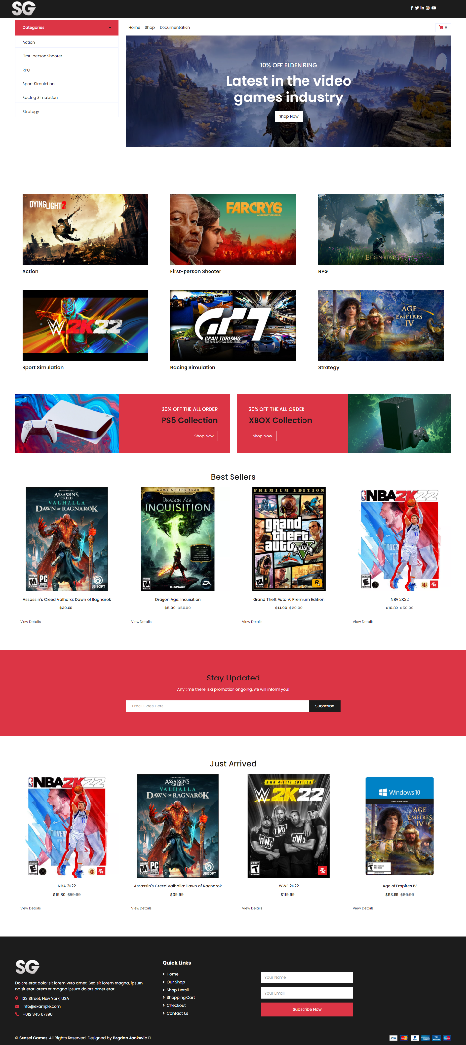

Navigacija se učitava dinamički AJAX-om iz JSON fajla, takođe prisutan je i meni za mobilne uređaje



Takođe, na svakoj stranici moguće je pristupiti korpi, a sadržaj se učitava iz Local Storage (na osnovu toga šta je lokalno dodato na klijentskom delu).

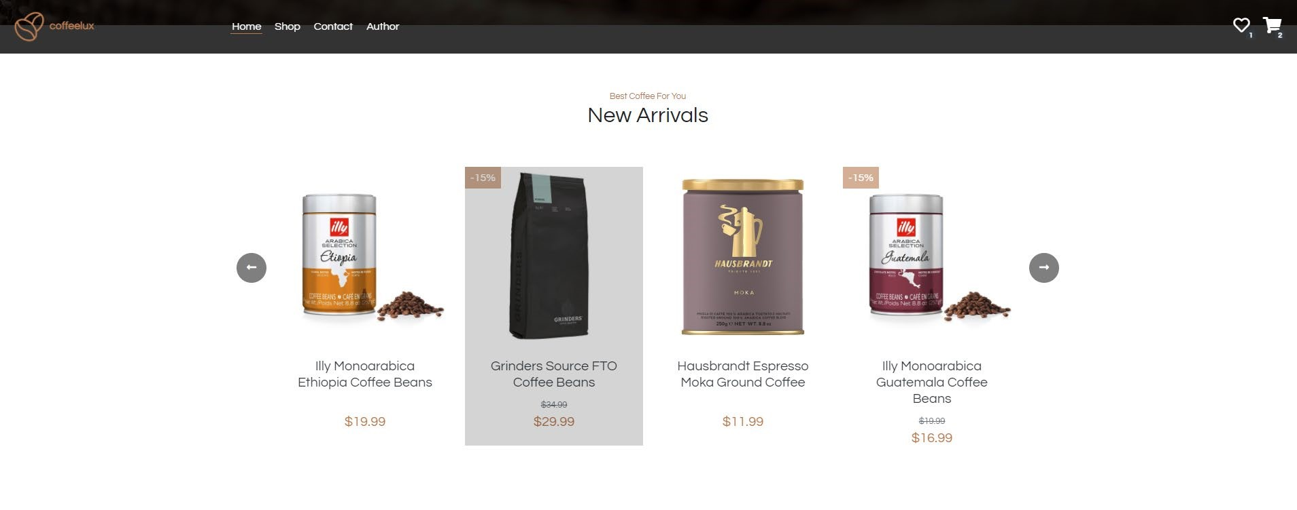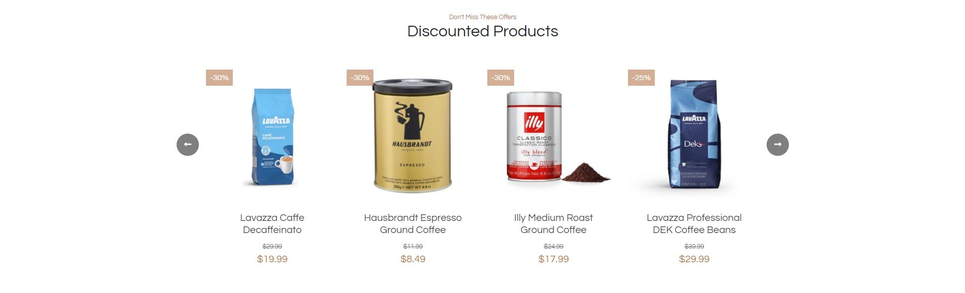

Skrolovanjem se dolazi do slajdera sa proizvodima, isto realizovanih pomoću slick plugina. Prvo se prikazuje nekoliko najnovijih proizvoda, a ispod se nalaze proizvodi na popustu. Klikom na neki od proizvoda otvara se modal sa više informacija o njemu. Isti modal se nalazi i na stranici za prodavnicu.

Ovo je realizovano jednostavnim filtriranjem i sortitranjem proizvoda preuzetih iz JSON fajla pomoću AJAX-a.

### 2.3.2 shop.html

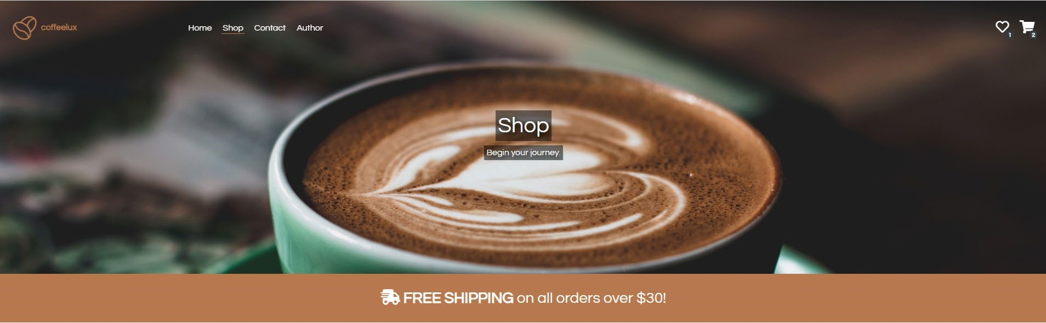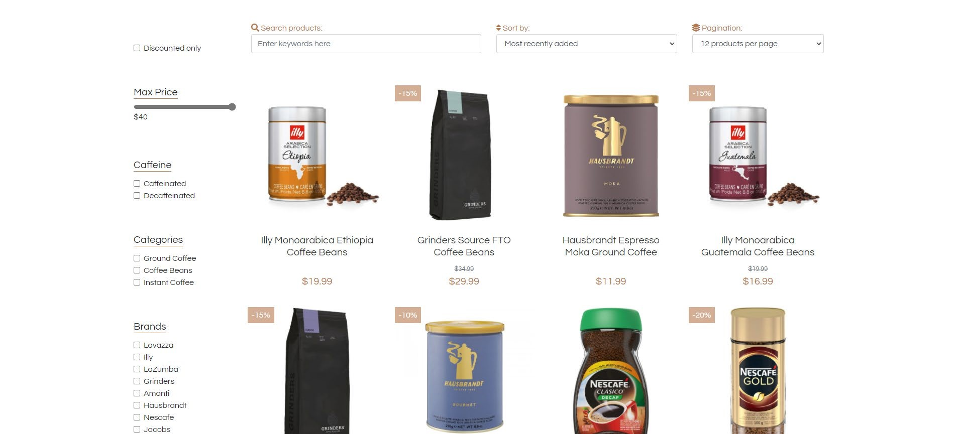

Na ovoj stranici nalaze se svi proizvodi, kao i razne opcije za filtriranje (maks. cena, brendovi, da li je prisutan kofein itd.), sortiranje, pretragu i straničenje. Svi proizvodi, kategorije, brendovi i aromatičnost preuzimaju se iz JSON fajlova upotrebom AJAX-a.

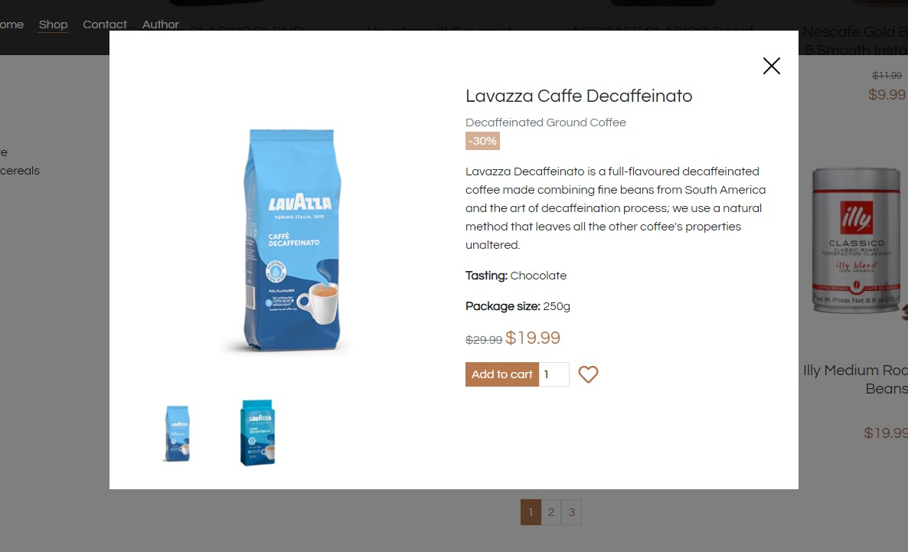

Klikom na bilo koji od proizvoda otvara se modal, koji se dinamički popunjava informacijama o izabranom proizvodu. Ovde su prikazane sve slike koje taj proizvod poseduje, a klikom na jednu od njih dobija se uvećan prikaz te slike.

Takođe, korisniku se nudi da izabere količinu i taj proizvod doda u korpu, kao i da doda proizvod na listu želja. Na taj način informacije će biti upisanje u Local Storage i biti dostupne otvaranjem sidebarova za listu želja, odnosno korpu.

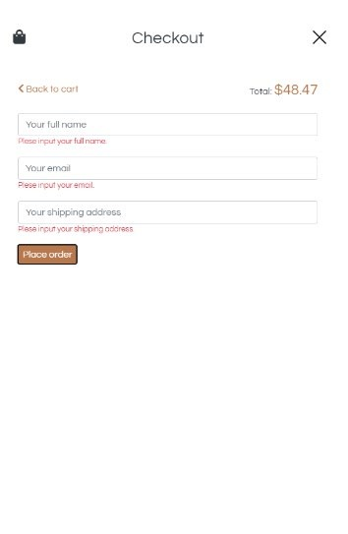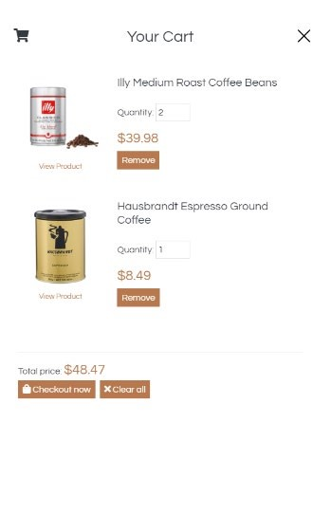

Ulaskom u korpu, prikazuju se dodati proizvodi sa opcijama brisanja i izmene količine, kao i ukupan iznos svih proizvoda.

Ako je iznos manji od predviđenog za besplatnu dostavu onda se uključuje i cena dostave.

Klikom na dugme za kupovinu dolazi se do forme za naručivanje. Podaci se proveravaju regularnim izrazima i korisnik se obaveštava o krajnjem ishodu.

### 2.3.3 contact.html

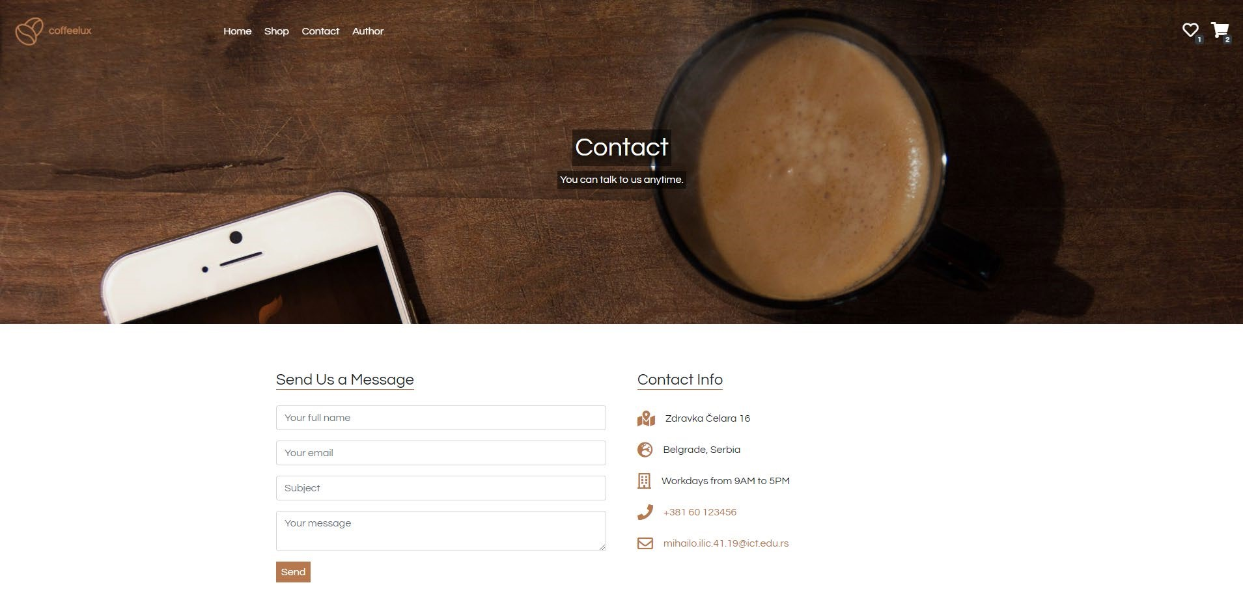

Na ovoj stranici nalaze se kontakt forma i informacije o drugim opcijama za kontakt.

Klikom na dugme za slanje poruke svi uneti podaci se prethodno proveravaju regularnim izrazima. Ako neko polje nije dobro popunjeno, korisniku se ispisuju detaljne informacije o tome šta nije u redu.

Informacije o dugim opcijama za kontakt (zajedno sa klasama za web ikonice) se čitaju iz JSON fajla upotrebom

AJAX-a.

### 2.3.4 author.html

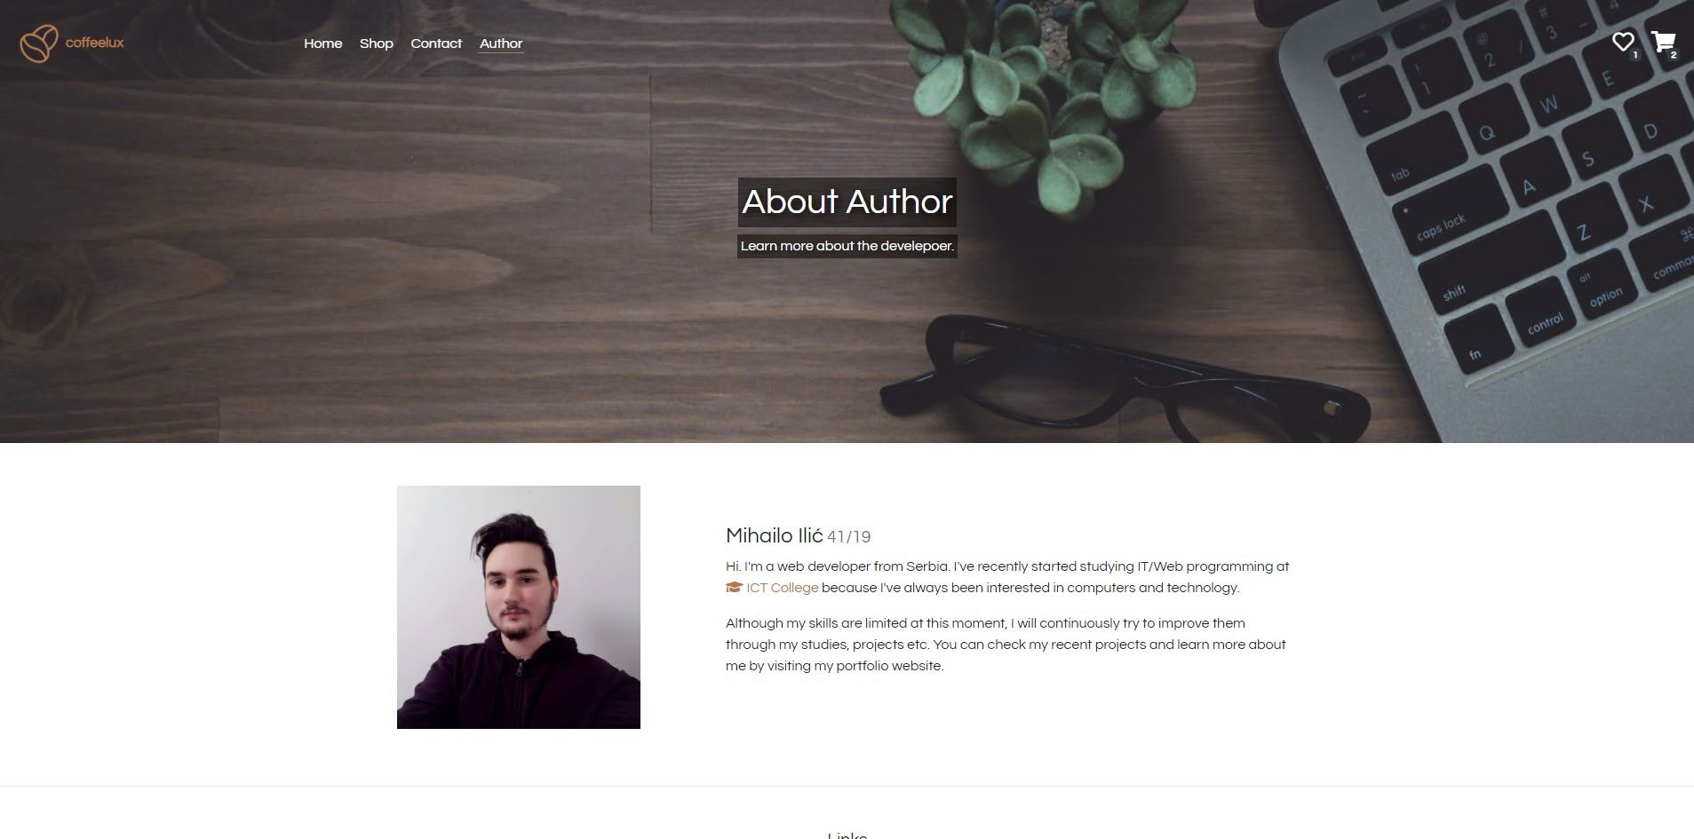

Na ovoj stranici ne postoje nikakve posebne funkcionalnosti, osim onih koje su prisutne na svim stranicama (navigacija, korpa, lista želja).

# 3. Kodovi

## 3.1 HTML

### 3.1.1 index.html

<!DOCTYPE html>

<html lang="en">

<head>

<meta charset="UTF-8">

<meta name="viewport" content="width=device-width, initial-scale=1.0">

<meta name="description" content="Find the best authentic coffee blend for you. Che ck out our online shop and get yours today. May your coffee kick in before reality does ."/>

<meta name="keywords" content="coffee, shop, quality, authentic"/>

<meta name="author" content="Mihailo Ilic"/>

<title>coffeelux | Quality & Authentic Coffee Shop</title>

<link rel="shortcut icon" href="favicon.ico" type="image/x-icon"/>

<link rel="stylesheet" type="text/css" href="https://cdnjs.cloudflare.com/ajax/libs

/font-awesome/5.15.2/css/all.min.css"/>

<link rel="stylesheet" type="text/css" href="assets/css/bootstrap.min.css"/>

<link rel="stylesheet" type="text/css" href="assets/slick/slick.css"/>

<link rel="stylesheet" type="text/css" href="assets/css/style.css"/>

</head>

<body>

<!-- *UCITAVANJE* -->

<div id="loading" class="align-items-center justify-content-center">

<img src="assets/img/loading.gif" alt="loading"/>

</div>

<!-- *NAVIGACIJA* -->

<header id="header" class="position-fixed w-100 m-0 row align-items-center textwhite">

<div class="col-5 col-md-3 col-lg-2">

<!-- *logo* -->

<a class="font-weight-bold" href="index.html">

<img id="logo" src="assets/img/logo.png"/><span id="logotitle">coffeelux</span>

</a>

</div>

<!-- *glavni meni* -->

<nav class="col-6 col-lg-7 d-none d-md-block">

<ul id="menu" class="w-100 m-0 d-flex justify-content-start">

</ul>

</nav>

<!-- *lista zelja, korpa, taster za meni* -->

<div id="side-togglers" class="col-7 col-md-3 text-right">

<a id="wishlist-button" class="position-relative mx-2" href="#!">

<span class="far fa-heart"></span><span class="badge badge-

|  |
| --- |
| dark"></span>  </a>  <a id="cart-button" class="position-relative mx-2" href="#!">  <span class="fas fa-shopping-cart"></span><span class="badge badgedark">1</span>  </a>  <a id="menu-button" class="position-relative d-inline d-md-none mx2" href="#!">  <span class="fas fa-bars"></span>  </a>  </div>  <!-- *meni za male ekrane* -->  <nav id="responsive-menu-wrapper" class="position-fixed w-100 py-3 bgdarkTransparent d-md-none">  <ul id="responsive-menu" class="w-100 m-0 d-flex flex-column align-itemscenter">  </ul>  </nav>  </header>  <!-- *SIDEBAR ZA LISTU ZELJA I KORPU* -->  <div id="sidebar-fix"></div>  <div id="sidebar-overlay" class="overflow-hidden">  <div id="sidebar" class="h-100 text-dark py-5 px-4 p-md-5">  <span id="sidebar-icon"></span>  <a href="#!" id="close-sidebar">  <div id="close-sidebar-wrapper">  <span class="close-button-slash"></span>  <span class="close-button-slash"></span>  </div>  </a>  <h3 id="sidebar-title" class="text-center"></h3>  <div id="sidebar-content">  </div>  </div>  </div>  <!-- *modal za proizvode* -->  <div id="product-modal-overlay">  <div id="product-modal-wrapper" class="d-flex justify-content-center alignitems-start py-5">  <div id="product-modal">  <div class="position-relative">  <a href="#!" id="close-product-modal">  <div id="close-product-modal-wrapper">  <span class="close-button-slash"></span>  <span class="close-button-slash"></span>  </div> |

</a>

</div>

|  |
| --- |
| <div id="product-modal-content" class="mx-0 mt-5 p-4 row">  <div id="product-modal-images" class="col-12 col-md-6"> <img src="assets/img/illy-cup.jpg" id="product-modalimage" alt="" class="img-fluid"/>  <div id="product-modal-all-images" class="row mt-2 mx-0"></div> </div>  <div id="product-modal-info" class="col-12 col-md-6 d-flex flexcolumn">  <h4 id="product-modal-title" class="mt-4 mt-md-0"></h4>  <p id="product-modal-category" class="text-muted m-0"></p>  <div id="product-modal-discount-wrapper">  <span class="product-modal-discount d-inline text-white p-  1"></span>  </div>  <p id="product-modal-description" class="mt-3"></p> <p>  <span class="font-weight-bold">Tasting: </span>  <span id="product-modal-tasting"></span>  </p>  <p>  <span class="font-weight-bold">Package size: </span>  <span id="product-modal-package-size"></span>  </p>  <div>  <s id="product-modal-old-price" class="text-muted"></s>  <span id="product-modal-new-price" class="colorprimary h4"></span>  </div>  <div class="mt-3">  <a href="#!" class="primary-button p-2 text-white" id="addto-cart">Add to cart</a><input type="number" class="cart-item-quantity pl-1 rounded0 border" value="1" min="1", max="99" onchange="if (this.value<1) {this.value=1;} if(th is.value>99){this.value=99;}"/>  <a href="#!" class="ml-2" id="add-to-wishlist">  <span class="far fa-heart"></span>  </a>  </div>  </div>  </div>  </div>  </div>  </div>  <!-- *HOME SADRZAJ* -->  <main id="home">  <!-- *slajder* -->  <section id="hero" class="d-flex flex-column align-items-center justify- |

content-center text-white text-center">

<h1 class="hero-text">Quality & Authentic Coffee</h1>

|  |
| --- |
| <p class="herotext">Find the best coffee blend for you. Check out our online shop and get yours today  . May your coffee kick in before reality does.</p>  <a href="#new-arrivals-wrapper" class="hero-button button mt-  3">Check it out</a>  <div id="slider">  </div> </section>  <section id="new-arrivals-wrapper" class="container pt-5">  <p class="small text-center m-0 mt-5 color-primary">Best Coffee For You</p>  <h2 class="text-center mb-5">New Arrivals</h2>  <div id="new-arrivals" class="position-relative row">  </div> </section>  <section id="discounted-wrapper" class="container pt-4">  <p class="small text-center m-0 mt-5 colorprimary">Don't Miss These Offers</p>  <h2 class="text-center mb-5">Discounted Products</h2>  <div id="discounted" class="position-relative row">  </div> </section>  <section id="free-shipping-banner" class="d-flex justify-content-center alignitems-center text-white">  <h3 class="m-4 p-1"><span class="font-weight-bold"><span class="fas fashipping-fast"></span> FREE SHIPPING</span> on all orders over $30!</h3>  </section>  <section id="visit-shop" class="d-flex flex-column align-items-center justifycontent-center p-5">  <h2 class="mt-5 p-2 text-white bgdarkTransparent">Haven't Found the Right Coffee Yet?</h3>  <p class="p-1 text-white bgdarkTransparent">Don't worry! We have a wide variety of choices. Please visit our shop for a full list.</p>  <a href="shop.html" class="button mb-5">Visit shop</a>  </section>  </main>  <footer class="row container mx-auto align-items-center mt-4 py-4">  <div id="footer-company-info" class="col-12 col-md-4 text-center">  <a class="font-weight-bold" href="index.html">  <img src="assets/img/logo.png" class=""/><span>coffeelux</span> </a>  <p class="text-muter text-center">Quality & Authentic Coffee</p> </div>  <div id="footer-links" class="col-12 col-md-4 text-center mt-5 mt-md-0">  <h5 id="footer-links-title" class="d-inline">Links</h5>  <ul class="mt-2"> |

<li>

<a href="documentation.pdf" target="_blank"><span class="far fa-

file-pdf"></span> Documentation</a>

</li>

<li> <a href="assets/js/main.js" target="_blank"><span class="far fafile-code"></span> main.js</a>

</li>

<li>

<a href="sitemap.xml" target="_blank"><span class="fas fasitemap"></span> Sitemap</a>

</li>

</ul>

</div>

<p class="col-12 col-md-4 text-center text-muted mt-5 mt-md-

0">Mihailo Ilic 41/19</p>

</footer>

<script type="text/javascript" src="assets/js/jquery-3.5.1.min.js"></script>

<script type="text/javascript" src="assets/slick/slick.min.js"></script>

<script type="text/javascript" src="assets/js/main.js"></script>

</body>

</html>

### 3.1.2 shop.html

<!DOCTYPE html>

<html lang="en">

<head>

<meta charset="UTF-8">

<meta name="viewport" content="width=device-width, initial-scale=1.0">

<meta name="description" content="Find the best authentic coffee blend for you. Che ck out our online shop and get yours today. May your coffee kick in before reality does ."/>

<meta name="keywords" content="coffee, shop, quality, authentic"/>

<meta name="author" content="Mihailo Ilic"/>

<title>coffeelux | Quality & Authentic Coffee Shop</title>

<link rel="shortcut icon" href="favicon.ico" type="image/x-icon"/>

<link rel="stylesheet" type="text/css" href="https://cdnjs.cloudflare.com/ajax/libs

/font-awesome/5.15.2/css/all.min.css"/>

<link rel="stylesheet" type="text/css" href="assets/css/bootstrap.min.css"/>

<link rel="stylesheet" type="text/css" href="assets/css/style.css"/>

</head>

<body>

<!-- *UCITAVANJE* -->

<div id="loading" class="align-items-center justify-content-center">

<img src="assets/img/loading.gif" alt="loading"/>

</div>

|  |
| --- |
| <!-- *NAVIGACIJA* -->  <header id="header" class="position-fixed w-100 m-0 row align-items-center textwhite">  <div class="col-5 col-md-3 col-lg-2">  <!-- *logo* -->  <a class="font-weight-bold" href="index.html">  <img id="logo" src="assets/img/logo.png"/><span id="logotitle">coffeelux</span>  </a>  </div>  <!-- *glavni meni* -->  <nav class="col-6 col-lg-7 d-none d-md-block">  <ul id="menu" class="w-100 m-0 d-flex justify-content-start">  </ul>  </nav>  <!-- *lista zelja, korpa, taster za meni* -->  <div id="side-togglers" class="col-7 col-md-3 text-right">  <a id="wishlist-button" class="position-relative mx-2" href="#!"> <span class="far fa-heart"></span><span class="badge badgedark"></span>  </a>  <a id="cart-button" class="position-relative mx-2" href="#!">  <span class="fas fa-shopping-cart"></span><span class="badge badgedark">1</span>  </a>  <a id="menu-button" class="position-relative d-inline d-md-none mx2" href="#!">  <span class="fas fa-bars"></span>  </a>  </div>  <!-- *meni za male ekrane* -->  <nav id="responsive-menu-wrapper" class="position-fixed w-100 py-3 bgdarkTransparent d-md-none">  <ul id="responsive-menu" class="w-100 m-0 d-flex flex-column align-itemscenter">  </ul>  </nav>  </header>  <!-- *SIDEBAR ZA LISTU ZELJA I KORPU* -->  <div id="sidebar-fix"></div>  <div id="sidebar-overlay" class="overflow-hidden"> <div id="sidebar" class="h-100 text-dark p-5">  <span id="sidebar-icon"></span>  <a href="#!" id="close-sidebar">  <div id="close-sidebar-wrapper">  <span class="close-button-slash"></span>  <span class="close-button-slash"></span> |

</div>

</a>

|  |
| --- |
| <h3 id="sidebar-title" class="text-center"></h3>  <div id="sidebar-content"></div>  </div>  </div>  <!-- *modal za proizvode* -->  <div id="product-modal-overlay">  <div id="product-modal-wrapper" class="d-flex justify-content-center alignitems-start py-5">  <div id="product-modal">  <div class="position-relative">  <a href="#!" id="close-product-modal">  <div id="close-product-modal-wrapper">  <span class="close-button-slash"></span>  <span class="close-button-slash"></span>  </div>  </a>  </div>  <div id="product-modal-content" class="mx-0 mt-5 p-4 row">  <div id="product-modal-images" class="col-12 col-md-6"> <img src="assets/img/illy-cup.jpg" id="product-modalimage" alt="" class="img-fluid"/>  <div id="product-modal-all-images" class="row mt-2 mx-0"></div> </div>  <div id="product-modal-info" class="col-12 col-md-6 d-flex flexcolumn">  <h4 id="product-modal-title" class="mt-4 mt-md-0"></h4>  <p id="product-modal-category" class="text-muted m-0"></p>  <div id="product-modal-discount-wrapper">  <span class="product-modal-discount d-inline text-white p-  1"></span>  </div>  <p id="product-modal-description" class="mt-3"></p> <p>  <span class="font-weight-bold">Tasting: </span>  <span id="product-modal-tasting"></span>  </p>  <p>  <span class="font-weight-bold">Package size: </span>  <span id="product-modal-package-size"></span>  </p>  <div>  <s id="product-modal-old-price" class="text-muted"></s>  <span id="product-modal-new-price" class="colorprimary h4"></span>  </div> |

<div class="mt-3">

<a href="#!" class="primary-button p-2 text-white" id="add-

|  |
| --- |
| to-cart">Add to cart</a><input type="number" class="cart-item-quantity pl-1 rounded0 border" value="1" min="1", max="99" onchange="if (this.value<1) {this.value=1;} if(th is.value>99){this.value=99;}"/>  <a href="#!" class="ml-2" id="add-to-wishlist">  <span class="far fa-heart"></span>  </a>  </div>  </div>  </div>  </div>  </div>  </div>  <!-- *SHOP SADRZAJ* -->  <main id="shop">  <section id="shop-image" class="page-image d-flex flex-column justify-contentcenter align-items-center">  <h1 class="text-white p-1">Shop</h1>  <h2 class="text-white h6 p-1">Begin your journey.</h2>  </section>  <section id="free-shipping-banner" class="d-flex justify-content-center alignitems-center text-white">  <h3 class="m-4 p-1"><span class="font-weight-bold"><span class="fas fashipping-fast"></span> FREE SHIPPING</span> on all orders over $30!</h3>  </section>  <div id="shop-products" class="row mx-auto p-3 p-lg-5">  <div id="shop-products-filters" class="col-12 col-sm-4 col-md-3 col-xl-  2 mt-4">  <div>  <a href="#!" id="clear-filters"><span class="fas fatimes"></span> Clear all filters</a>&nbsp;  </div>  <ul id="filter-general" class="mt-3">  <li class="form-check">  <input class="form-check-input" type="checkbox" id="filterdiscount" value="discount"/>  <label class="form-check-label" for="filter-discount">  Discounted only  </label>  </li>  </ul>  <h5 class="mt-5">Max Price</h5>  <div class="form-group">  <input type="range" class="form-control-range" id="maxprice" min="1" max="100">  <div class="d-flex justify-content-between">  <label for="max-price"></label>  <a href="#!" id="clear-max-price" class="text-red">Clear</a> |

</div>

</div>

|  |
| --- |
| <h5 class="mt-5">Caffeine</h5>  <ul id="filter-caffeine" class="mt-1">  <li class="form-check">  <input class="form-check-input" type="checkbox" id="filtercaffeinated" value="false"/>  <label class="form-check-label" for="filter-caffeinated">  Caffeinated  </label>  </li>  <li class="form-check">  <input class="form-check-input" type="checkbox" id="filterdecaffeinated" value="true"/>  <label class="form-check-label" for="filter-decaffeinated">  Decaffeinated  </label>  </li>  </ul>  <h5 class="mt-5">Categories</h5>  <ul id="filter-categories" class="mt-1">  </ul>  <h5 class="mt-5">Brands</h5>  <ul id="filter-brands" class="mt-1">  </ul>  <h5 class="mt-5">Tasting</h5>  <ul id="filter-tasting" class="mt-1">  </ul>  </div>  <div id="shop-products-grid-wrapper" class="col-12 col-sm-8 col-md-9 colxl-10 mt-3">  <div id="shop-products-view" class="row justify-content-between">  <div class="col-12 col-sm-12 col-xl-5 my-2 m-md-none">  <span><span class="fas fasearch"></span> Search products:</span>  <input type="text" class="form-control" value="" id="searchproducts" placeholder="Enter keywords here"/>  </div>  <div class="col-12 col-sm-6 col-xl-4 my-2 m-md-none">  <span><span class="fas fa-sort"></span> Sort by:</span>  <select class="form-control" id="sort-products">  <option value="date">Most recently added</option>  <option value="discount">Most discount</option>  <option value="price-asc">Price ascending</option>  <option value="price-desc">Price descending</option>  <option value="name-asc">Name ascending</option>  <option value="name-desc">Name descending</option> |

</select>

</div>

<div class="col-12 col-sm-6 col-xl-3 my-2 m-md-none">

|  |
| --- |
| <span><span class="fas fa-layergroup"></span> Pagination:</span>  <select class="form-control" id="paginate-products">  <option value="0">None</option>  <option value="12" selected="selected">12 products per page </option>  <option value="24">24 products per page</option>  </select>  </div>  </div>  <div id="shop-products-grid" class="row mt-5">    </div>  <div id="pagination" class="mt-5 text-center">  </div>  </div>  </div>  </main>  <hr/>  <footer class="row container mx-auto align-items-center mt-4 py-4">  <div id="footer-company-info" class="col-12 col-md-4 text-center">  <a class="font-weight-bold" href="index.html">  <img src="assets/img/logo.png" class=""/><span>coffeelux</span> </a>  <p class="text-muter text-center">Quality & Authentic Coffee</p> </div>  <div id="footer-links" class="col-12 col-md-4 text-center mt-5 mt-md-0">  <h5 id="footer-links-title" class="d-inline">Links</h5>  <ul class="mt-2">  <li> <a href="documentation.pdf" target="_blank"><span class="far fafile-pdf"></span> Documentation</a>  </li>  <li> <a href="assets/js/main.js" target="_blank"><span class="far fafile-code"></span> main.js</a>  </li>  <li>  <a href="sitemap.xml" target="_blank"><span class="fas fasitemap"></span> Sitemap</a>  </li>    </ul>  </div>  <p class="col-12 col-md-4 text-center text-muted mt-5 mt-md- |

0">Mihailo Ilic 41/19</p>

</footer>

<script type="text/javascript" src="assets/js/jquery-3.5.1.min.js"></script>

<script type="text/javascript" src="assets/js/main.js"></script>

</body>

</html>

### 3.1.3 contact.html

|  |
| --- |
| <!DOCTYPE html>  <html lang="en">  <head>  <meta charset="UTF-8">  <meta name="viewport" content="width=device-width, initial-scale=1.0">  <meta name="description" content="Find the best authentic coffee blend for you. Che ck out our online shop and get yours today. May your coffee kick in before reality does ."/>  <meta name="keywords" content="coffee, shop, quality, authentic"/>  <meta name="author" content="Mihailo Ilic"/>  <title>coffeelux | Quality & Authentic Coffee Shop</title>  <link rel="shortcut icon" href="favicon.ico" type="image/x-icon"/>  <link rel="stylesheet" type="text/css" href="https://cdnjs.cloudflare.com/ajax/libs  /font-awesome/5.15.2/css/all.min.css"/>  <link rel="stylesheet" type="text/css" href="assets/css/bootstrap.min.css"/>  <link rel="stylesheet" type="text/css" href="assets/css/style.css"/>  </head>  <body>  <!-- *UCITAVANJE* -->  <div id="loading" class="align-items-center justify-content-center">  <img src="assets/img/loading.gif" alt="loading"/>  </div>  <!-- *NAVIGACIJA* -->  <header id="header" class="position-fixed w-100 m-0 row align-items-center textwhite">  <div class="col-5 col-md-3 col-lg-2">  <!-- *logo* -->  <a class="font-weight-bold" href="index.html">  <img id="logo" src="assets/img/logo.png"/><span id="logotitle">coffeelux</span>  </a>  </div>  <!-- *glavni meni* -->  <nav class="col-6 col-lg-7 d-none d-md-block">  <ul id="menu" class="w-100 m-0 d-flex justify-content-start"> </ul> |

</nav>

<!-- *lista zelja, korpa, taster za meni* -->

<div id="side-togglers" class="col-7 col-md-3 text-right">

|  |
| --- |
| <a id="wishlist-button" class="position-relative mx-2" href="#!"> <span class="far fa-heart"></span><span class="badge badgedark"></span>  </a>  <a id="cart-button" class="position-relative mx-2" href="#!">  <span class="fas fa-shopping-cart"></span><span class="badge badgedark">1</span>  </a>  <a id="menu-button" class="position-relative d-inline d-md-none mx2" href="#!">  <span class="fas fa-bars"></span>  </a>  </div>  <!-- *meni za male ekrane* -->  <nav id="responsive-menu-wrapper" class="position-fixed w-100 py-3 bgdarkTransparent d-md-none">  <ul id="responsive-menu" class="w-100 m-0 d-flex flex-column align-itemscenter">  </ul>  </nav>  </header>  <!-- *SIDEBAR ZA LISTU ZELJA I KORPU* -->  <div id="sidebar-fix"></div>  <div id="sidebar-overlay" class="overflow-hidden"> <div id="sidebar" class="h-100 text-dark p-5">  <span id="sidebar-icon"></span>  <a href="#!" id="close-sidebar">  <div id="close-sidebar-wrapper">  <span class="close-button-slash"></span>  <span class="close-button-slash"></span>  </div>  </a>  <h3 id="sidebar-title" class="text-center"></h3>  <div id="sidebar-content"></div>  </div>  </div>  <!-- *modal za proizvode* -->  <div id="product-modal-overlay">  <div id="product-modal-wrapper" class="d-flex justify-content-center alignitems-start py-5">  <div id="product-modal">  <div class="position-relative">  <a href="#!" id="close-product-modal">  <div id="close-product-modal-wrapper">  <span class="close-button-slash"></span>  <span class="close-button-slash"></span> |

</div>

</a>

|  |
| --- |
| </div>  <div id="product-modal-content" class="mx-0 mt-5 p-4 row">  <div id="product-modal-images" class="col-12 col-md-6"> <img src="assets/img/illy-cup.jpg" id="product-modalimage" alt="" class="img-fluid"/>  <div id="product-modal-all-images" class="row mt-2 mx-0"></div> </div>  <div id="product-modal-info" class="col-12 col-md-6 d-flex flexcolumn">  <h4 id="product-modal-title" class="mt-4 mt-md-0"></h4>  <p id="product-modal-category" class="text-muted m-0"></p>  <div id="product-modal-discount-wrapper">  <span class="product-modal-discount d-inline text-white p-  1"></span>  </div>  <p id="product-modal-description" class="mt-3"></p> <p>  <span class="font-weight-bold">Tasting: </span>  <span id="product-modal-tasting"></span>  </p>  <p>  <span class="font-weight-bold">Package size: </span>  <span id="product-modal-package-size"></span>  </p>  <div>  <s id="product-modal-old-price" class="text-muted"></s>  <span id="product-modal-new-price" class="colorprimary h4"></span>  </div>  <div class="mt-3">  <a href="#!" class="primary-button p-2 text-white" id="addto-cart">Add to cart</a><input type="number" class="cart-item-quantity pl-1 rounded0 border" value="1" min="1", max="99" onchange="if (this.value<1) {this.value=1;} if(th is.value>99){this.value=99;}"/>  <a href="#!" class="ml-2" id="add-to-wishlist">  <span class="far fa-heart"></span>  </a>  </div>  </div>  </div>  </div>  </div>  </div>  <!-- *CONTACT SADRZAJ* -->  <main id="contact"> |

<section id="contact-image" class="page-image d-flex flex-column justify-

|  |
| --- |
| content-center align-items-center">  <h1 class="text-white p-1">Contact</h1>  <h2 class="text-white h6 p-1">You can talk to us anytime.</h2> </section>  <section id="contact-content" class="row container mx-auto my-5">  <div id="contact-form-wrapper" class="col-12 col-md-6 p-4">  <h3 class="h4 d-inline-block">Send Us a Message</h3>  <form id="contact-form" class="mt-3" method="post" action="#!">  <div class="form-group">  <input type="text" class="formcontrol" placeholder="Your full name" id="contact-name"/>  </div>  <div class="form-group">  <input type="text" class="formcontrol" placeholder="Your email" id="contact-email"/>  </div>  <div class="form-group">  <input type="text" class="formcontrol" placeholder="Subject" id="contact-subject"/>  </div>  <div class="form-group"> <textarea class="formcontrol" placeholder="Your message" id="contact-message"></textarea>  </div>  <button type="submit" id="contact-submit-button" class="primarybutton p-1 px-2 border-0">Send</button>  </form>  </div>  <div id="contact-info-wrapper" class="col-12 col-md-6 p-4">  <h3 class="h4 d-inline-block">Contact Info</h3>  <ul id="contact-info" class="mt-3">  </ul>  </div> </section>  </main>  <hr/>  <footer class="row container mx-auto align-items-center mt-4 py-4">  <div id="footer-company-info" class="col-12 col-md-4 text-center">  <a class="font-weight-bold" href="index.html">  <img src="assets/img/logo.png" class=""/><span>coffeelux</span> </a>  <p class="text-muter text-center">Quality & Authentic Coffee</p> </div>  <div id="footer-links" class="col-12 col-md-4 text-center mt-5 mt-md-0">  <h5 id="footer-links-title" class="d-inline">Links</h5>  <ul class="mt-2">  <li> |

<a href="documentation.pdf" target="_blank"><span class="far fa-

file-pdf"></span> Documentation</a>

</li>

<li> <a href="assets/js/main.js" target="_blank"><span class="far fafile-code"></span> main.js</a>

</li>

<li>

<a href="sitemap.xml" target="_blank"><span class="fas fasitemap"></span> Sitemap</a>

</li>

</ul>

</div>

<p class="col-12 col-md-4 text-center text-muted mt-5 mt-md-

0">Mihailo Ilic 41/19</p>

</footer>

<script type="text/javascript" src="assets/js/jquery-3.5.1.min.js"></script>

<script type="text/javascript" src="assets/js/main.js"></script>

</body>

</html>

### 3.1.4 author.html

<!DOCTYPE html>

<html lang="en">

<head>

<meta charset="UTF-8">

<meta name="viewport" content="width=device-width, initial-scale=1.0">

<meta name="description" content="Find the best authentic coffee blend for you. Che ck out our online shop and get yours today. May your coffee kick in before reality does ."/>

<meta name="keywords" content="coffee, shop, quality, authentic"/>

<meta name="author" content="Mihailo Ilic"/>

<title>coffeelux | Quality & Authentic Coffee Shop</title>

<link rel="shortcut icon" href="favicon.ico" type="image/x-icon"/>

<link rel="stylesheet" type="text/css" href="https://cdnjs.cloudflare.com/ajax/libs

/font-awesome/5.15.2/css/all.min.css"/>

<link rel="stylesheet" type="text/css" href="assets/css/bootstrap.min.css"/>

<link rel="stylesheet" type="text/css" href="assets/css/style.css"/>

</head>

<body>

<!-- *UCITAVANJE* -->

<div id="loading" class="align-items-center justify-content-center">

<img src="assets/img/loading.gif" alt="loading"/>

</div>

|  |
| --- |
| <!-- *NAVIGACIJA* -->  <header id="header" class="position-fixed w-100 m-0 row align-items-center textwhite">  <div class="col-5 col-md-3 col-lg-2">  <!-- *logo* -->  <a class="font-weight-bold" href="index.html">  <img id="logo" src="assets/img/logo.png"/><span id="logotitle">coffeelux</span>  </a>  </div>  <!-- *glavni meni* -->  <nav class="col-6 col-lg-7 d-none d-md-block">  <ul id="menu" class="w-100 m-0 d-flex justify-content-start">  </ul>  </nav>  <!-- *lista zelja, korpa, taster za meni* -->  <div id="side-togglers" class="col-7 col-md-3 text-right">  <a id="wishlist-button" class="position-relative mx-2" href="#!"> <span class="far fa-heart"></span><span class="badge badgedark"></span>  </a>  <a id="cart-button" class="position-relative mx-2" href="#!">  <span class="fas fa-shopping-cart"></span><span class="badge badgedark">1</span>  </a>  <a id="menu-button" class="position-relative d-inline d-md-none mx2" href="#!">  <span class="fas fa-bars"></span>  </a>  </div>  <!-- *meni za male ekrane* -->  <nav id="responsive-menu-wrapper" class="position-fixed w-100 py-3 bgdarkTransparent d-md-none">  <ul id="responsive-menu" class="w-100 m-0 d-flex flex-column align-itemscenter">  </ul>  </nav>  </header>  <!-- *SIDEBAR ZA LISTU ZELJA I KORPU* -->  <div id="sidebar-fix"></div>  <div id="sidebar-overlay" class="overflow-hidden"> <div id="sidebar" class="h-100 text-dark p-5">  <span id="sidebar-icon"></span>  <a href="#!" id="close-sidebar">  <div id="close-sidebar-wrapper">  <span class="close-button-slash"></span>  <span class="close-button-slash"></span> |

|  |
| --- |
| </div>  </a>  <h3 id="sidebar-title" class="text-center"></h3>  <div id="sidebar-content"></div>  </div>  </div>  <!-- *modal za proizvode* -->  <div id="product-modal-overlay">  <div id="product-modal-wrapper" class="d-flex justify-content-center alignitems-start py-5">  <div id="product-modal">  <div class="position-relative">  <a href="#!" id="close-product-modal">  <div id="close-product-modal-wrapper">  <span class="close-button-slash"></span>  <span class="close-button-slash"></span>  </div>  </a>  </div>  <div id="product-modal-content" class="mx-0 mt-5 p-4 row">  <div id="product-modal-images" class="col-12 col-md-6"> <img src="assets/img/illy-cup.jpg" id="product-modalimage" alt="" class="img-fluid"/>  <div id="product-modal-all-images" class="row mt-2 mx-0"></div> </div>  <div id="product-modal-info" class="col-12 col-md-6 d-flex flexcolumn">  <h4 id="product-modal-title" class="mt-4 mt-md-0"></h4>  <p id="product-modal-category" class="text-muted m-0"></p>  <div id="product-modal-discount-wrapper">  <span class="product-modal-discount d-inline text-white p-  1"></span>  </div>  <p id="product-modal-description" class="mt-3"></p> <p>  <span class="font-weight-bold">Tasting: </span>  <span id="product-modal-tasting"></span>  </p>  <p>  <span class="font-weight-bold">Package size: </span>  <span id="product-modal-package-size"></span>  </p>  <div>  <s id="product-modal-old-price" class="text-muted"></s>  <span id="product-modal-new-price" class="colorprimary h4"></span>  </div>  <div class="mt-3"> |
| <a href="#!" class="primary-button p-2 text-white" id="addto-cart">Add to cart</a><input type="number" class="cart-item-quantity pl-1 rounded0 border" value="1" min="1", max="99" onchange="if (this.value<1) {this.value=1;} if(th is.value>99){this.value=99;}"/>  <a href="#!" class="ml-2" id="add-to-wishlist">  <span class="far fa-heart"></span>  </a>  </div>  </div>  </div>  </div>  </div>  </div>  <!-- *AUTHOR SADRZAJ* -->  <main id="author">  <section id="author-image" class="page-image d-flex flex-column justifycontent-center align-items-center">  <h1 class="text-white p-1">About Author</h1>  <h2 class="text-white h6 p-1">Learn more about the develepoer.</h2> </section>  <section id="author-data" class="row container mx-auto justify-contentcenter align-items-center">  <div id="author-portrait" class="col-10 col-md-4 p-5 p-md-2 p-lg-5">  <img src="assets/img/author-portrait.jpg" class="imgfluid" alt="Author"/>  </div>  <div id="author-info" class="col-12 col-md-8 p-5">  <h4>Mihailo Ilić<small class="text-muted"> 41/19</small></h4>  <p>Hi. I'm a web developer from Serbia. I've recently started studying IT/Web programming at <a href="https://ict.edu.rs/" class="primarycolor" target="_blank"><span class="fa fa-graduationcap"></span> ICT College</a> because I've always been interested in computers and techn ology.</p>  <p>Although my skills are limited at this moment, I will continuously t ry to improve them through my studies, projects etc. You can check my recent projects a nd learn more about me by visiting my portfolio website.</p>  <a href="https://mihailoilic.github.io/portfolio" tager="_blank" class=  "primary-button p-2 border-0" id="">My portfolio website</a>  </div> </section>  </main>  <hr/>  <footer class="row container mx-auto align-items-center mt-4 py-4">  <div id="footer-company-info" class="col-12 col-md-4 text-center">  <a class="font-weight-bold" href="index.html">  <img src="assets/img/logo.png" class=""/><span>coffeelux</span> </a>  <p class="text-muter text-center">Quality & Authentic Coffee</p> |

</div>

<div id="footer-links" class="col-12 col-md-4 text-center mt-5 mt-md-0">

<h5 id="footer-links-title" class="d-inline">Links</h5>

<ul class="mt-2">

<li> <a href="documentation.pdf" target="_blank"><span class="far fafile-pdf"></span> Documentation</a>

</li>

<li> <a href="assets/js/main.js" target="_blank"><span class="far fafile-code"></span> main.js</a>

</li>

<li>

<a href="sitemap.xml" target="_blank"><span class="fas fasitemap"></span> Sitemap</a>

</li>

</ul>

</div>

<p class="col-12 col-md-4 text-center text-muted mt-5 mt-md-

0">Mihailo Ilic 41/19</p>

</footer>

<script type="text/javascript" src="assets/js/jquery-3.5.1.min.js"></script>

<script type="text/javascript" src="assets/js/main.js"></script>

</body>

</html>

## 3.2 CSS

### 3.2.1 assets/css/style.scss

$primary: #b8784e;

$primaryDark: #704a30;

$darkTrans: rgba(0,0,0,0.9);

|  |
| --- |
| $trans: rgba(0,0,0,.5);  * { margin: 0px; padding: 0px;  }  @font-face{ src: url("../fonts/Questrial-Regular.ttf"); font-family: "Questrial";  } html { scroll-behavior: smooth; ::-webkit-scrollbar { width: 10px;  }  ::-webkit-scrollbar-thumb { background-color: $primary;  &:hover{ background: rgba($primary, .8);  }  } } body { font-family: "Questrial";  } ul { list-style-type: none;  } a{ color: $primary; &, &:hover{ color: $primary; text-decoration: none;  }  } |

.color-primary { color: $primary; } .bg-darkTransparent{ background: rgba(#000, .8);

}

.button { color: #fff;

|  |
| --- |
| border: 1px solid $primary; padding: 7px; background: $darkTrans; transition: all .4s;  &:hover{ background-color: $trans; border-color: $primary; color: #fff;  }  }  .primary-button { color: #fff; background: $primary; height: 32px; transition: all .3s;  &:hover { background:rgba($primary, .8); color: #fff;  }  } input, select, textarea, .primary-button { transition: all .3s; &:focus, &:active { outline: none; border-color: $primary !important; box-shadow: 0 0 0 0.2rem rgba($primary,.25) !important;  }  }  #close-sidebar, #close-product-modal { position: absolute; top: 47px; right: 30px;  #close-sidebar-wrapper ,#close-product-modal-wrapper { width: 30px; height: 30px;  .close-button-slash { position: absolute; top: 15px; right: 0px; |

width: 30px; height: 2px; transform: rotate(45deg); background-color: #000; &:last-of-type{ transform: rotate(-45deg); }

}

} &#close-product-modal { top: 30px; right: 20px;

}

}

|  |
| --- |
| #loading { z-index: 1200; display: flex; position: fixed; top: 0; left: 0; background: #000; width: 100vw; height: 100vh;  }  #header { top: 0px; left: 0px; height: 100px; z-index: 1000; transition: all .3s; &.bg-darkTransparent{ height: 80px;  } #logo {  height: 60px;  }  #logo-title {  @media screen and (max-width: 400px){ display: none;  }  }  #menu, #responsive-menu { a { color: #fff; padding: 2px; &.active, &:hover{ border-bottom: 1px solid $primary;  } |

}

} #side-togglers{ a { color: #fff; .far, .fas{ font-size: 24px;

@media screen and (max-width: 400px){

|  |
| --- |
| font-size: 20px;  }  } .badge { position: absolute; font-size: 10px; bottom: -10px; right: -5px;  }  }  }  #responsive-menu-wrapper { display: none; top: 80px; left: 0px;  }    }  #sidebar-fix { display: none; z-index: 950; height: 100vh; width: 10px; position: absolute; background: rgba($primary,.7); backdrop-filter: blur(5px); top: 0px; right: 0px;  }  #sidebar-overlay { display: none; z-index: 1100; position: fixed; top: 0px; left: 0px; width: 100vw; height: 100vh; background: $trans;  #sidebar{ overflow-y: scroll; |

position: fixed; right: -700px; top: 0px; background: white; width: 100%;

@media screen and (min-width: 768px) {

width: 600px;

}

&::-webkit-scrollbar { width: 5px;

}

&::-webkit-scrollbar-thumb { background-color: rgba(0,0,0, .4);

}

|  |
| --- |
| #sidebar-icon{ position: absolute; font-size: 24px; left: 40px; top: 50px;  }  .sidebar-item{ .product-link { width: 30%; max-width: 150px;  } &>div{  width: 60%;  .cart-item-quantity{ width: 60px;  }  }  }  .form-success { color: rgba($primary, .6); font-size: 2em;  }  }  }  #home { #hero { max-width: 100vw; height: 100vh; background-image: url("../img/coffee-slider-1.webp"); background-size: cover;  .hero-text { max-width: 60%; z-index: 900; padding: 5px; |

background: $trans; text-shadow: 3px 3px 10px #000;

} .hero-button { z-index: 900;

}

@media screen and (min-width: 992px) { h1.hero-text{ font-size: 50px;

}

p.hero-text{ font-size: 20px; max-width: 50%;

}

|  |
| --- |
| }  #slider { position: absolute; top: 0px; left: 0px; width: 100%; height: inherit; .slick-track{ height: 100vh;  }  .slick-prev, .slick-next { position: absolute; top: 50vh; z-index: 900; background: rgba(0,0,0,.5); color: #fff; padding: 10px 15px; border-radius: 50%;  }  .slick-prev{ left: 15px;  }  .slick-next{ right: 15px;  } img { object-fit: cover;  }  }  }  }  #free-shipping-banner { background: $primary; |

}

#product-modal-overlay { display: none; z-index: 1100; position: fixed; top: 0;

left: 0; width: 100vw; height: 100vh; background: $trans; overflow-y: scroll; #product-modal-wrapper{ overflow-y: scroll; #product-modal{

|  |
| --- |
| background: white; width: 90%;  @media screen and (min-width: 992px){ width: 900px;  }  &::-webkit-scrollbar { width: 5px;  }  &::-webkit-scrollbar-thumb {  background-color: rgba(0,0,0, .4);  }  .product-modal-discount {  background: rgba($primary, .6);  }  }  #add-to-wishlist { span { position: relative; top: 5px;  font-size: 1.6em;  }  }  }    }  #new-arrivals, #discounted { margin: 0 80px;  @media screen and (min-width: 1300px) { margin: 0;  }  .slick-prev, .slick-next { position: absolute; top: 30%; z-index: 900; |

background: rgba(0,0,0,.5); color: #fff; padding: 10px 15px; border-radius: 50%;

}

.slick-prev{

left: -50px; } .slick-next{ right: -50px;

}

} .product-link { display: block;

|  |
| --- |
| transition: filter .2s;  &:hover{ filter: brightness(80%);  } .product-discount { position: absolute; top: 0px; left: 0px; background: rgba($primary, .6);    }  .product {  .product-price { font-size: 20px;  }  }  }  .cart-item-quantity { width: 40px; height: 32px;  }  #visit-shop{ background-image: url("../img/visit-shop.jpg"); background-attachment: fixed;  } footer {  #footer-company-info { img { width: 70px;  }  }  #footer-links{  #footer-links-title { border-bottom: 1px solid $primary; |

}

}

} .page-image { min-height: 500px; background-size: cover; background-attachment: fixed; h1,h2 { background: $trans; text-shadow: 3px 3px 10px #000;

}

}

//*SHOP* #shop-image{

|  |
| --- |
| background-image: url("../img/shop.jpg");  }  #shop-products { max-width: 1500px; #shop-products-filters { h5 { display: inline-block; border-bottom: 1px solid $primary;  }    }  #shop-products-grid-wrapper { span { color: $primary;  }  }  #pagination {  a.active { background: $primary; color: #fff; border-color: $primary !important;  }  }  }  //*CONTACT* #contact-image{ background-image: url("../img/contact.jpg");  }  #contact { h3 { border-bottom: 1px solid $primary;  }  #contact-info { span { |

font-size: 1.5em; color: $primary;

}

}

}

//*AUTHOR*

#author{ #author-image{ background-image: url("../img/author.jpg");

}

}

## 3.3 JavaScript

### 3.3.1 assets/js/main.js

|  |
| --- |
| const data = {  "shipping" : 4.99,  "forms" : {}  };  $(document).ready(function(){ initializePage();  });    //*INICIJALIZACIJA SVAKE STRANICE* async function initializePage(){ try{ data.nav = await fetchData("nav.json"); loadNav();  } catch(c){ console.log(`Error loading navigation! Status ${c}`);  $("#menu").append("<li>Error loading navigation. Try again later.</li>");  } try { data.products = await fetchData("products.json"); data.brands = await fetchData("brands.json"); data.categories = await fetchData("categories.json"); data.tasting = await fetchData("tasting.json");  } catch(c){ console.log(`Error loading products! Status ${c}`);  $("#new-arrivals, #shop-productsgrid").append(`<p>Error loading products! Try again later.</p>`);    } data.cart = getLocalStorageItem("cart"); data.wishList = getLocalStorageItem("wishlist"); refreshBadges();  loadSidebar(); loadProductsModal(); loadRegularExpressions();  pageRelatedFeatures(); |

$("#loading").fadeOut(1000);

}

|  |
| --- |
| function loadNav(){ for(link of data.nav) { let active = ""; if(window.location.pathname.includes(link.href)){ data.page = link.title; active = " active";  }  $("#menu, #responsive-menu").append(`<li class="m-  2"><a class="${active}" href="${link.href}">${link.title}</a></li>`);  } if(!data.page){  data.page = "Home";  $("#menu, #responsive-menu").find("a:first").addClass("active");  } navScrollEvent();  $(window).on("scroll",navScrollEvent);  $("#menu-button").click(function(){  $("#responsive-menu-wrapper").toggleClass("active").toggle(300); navScrollEvent();  }); } function navScrollEvent(){ if($(window).scrollTop() > 70 || $("#responsive-menu-wrapper").hasClass("active")){  $("#header").addClass("bg-darkTransparent");  } else {  $("#header").removeClass("bg-darkTransparent")  }  }    //*AJAX DOHVATANJE* function fetchData(filename){ return new Promise((resolve, reject)=>{  $.ajax({ url: `assets/data/${filename}`, method: "get", dataType: "json", success: function(data){ resolve(data);  }, error: function(xhr){ reject(xhr.status); |

}

});

});

}

//*OBRADA LOCAL STORAGE* function getLocalStorageItem(name){

|  |
| --- |
| let item = localStorage.getItem(name); if(item){ parsedItem = JSON.parse(item); if(parsedItem.length > 0){ return parsedItem;  } } return false;  } function removeLocalStorageItem(name){ data[name] = []; localStorage.removeItem(name); refreshBadges();  } function getCartProductIndexByID(id){ let productIndex = -1; data.cart.find((el,ind)=>{ if(el.id == id){ productIndex = ind; return true;  } return false;  }); return productIndex;  } function setCartProduct(productID, quantity, add = false){ if(data.cart){ let productIndex = getCartProductIndexByID(productID); if(productIndex > -1){ let newQuantity = quantity; if(add){ newQuantity += data.cart[productIndex].quantity;  } data.cart[productIndex].quantity = newQuantity;  } else { data.cart.push({"id": productID, "quantity": quantity});  } } else { data.cart = [{"id": productID, "quantity": quantity}];  } localStorage.setItem("cart", JSON.stringify(data.cart)); |

refreshBadges();

}

function removeCartProduct(productID){ data.cart.splice(getCartProductIndexByID(productID), 1);

|  |
| --- |
| localStorage.setItem("cart",JSON.stringify(data.cart)); refreshBadges();  } function setWishListProduct(productID){ if(data.wishList){ if(!data.wishList.includes(productID)){ data.wishList.push(productID);  } } else { data.wishList = [productID];  } localStorage.setItem("wishlist", JSON.stringify(data.wishList)); refreshBadges();  } function removeWishListProduct(productID){ for(i in data.wishList){ if (data.wishList[i] == productID){ data.wishList.splice(i,1); break;  } } localStorage.setItem("wishlist", JSON.stringify(data.wishList)); refreshBadges();  } function refreshBadges(){  $("#cart-button .badge").text(data.cart.length ? String(data.cart.length) : "");  $("#wishlistbutton .badge").text(data.wishList.length ? String(data.wishList.length) : "");  }    //*SIDEBAR - LISTA ZELJA I KORPA* function loadSidebar(){  $("#close-sidebar, #sidebar-overlay").click(hideSidebar);  $("#sidebar").click(function(event){event.stopPropagation()});  $("#cart-button").click(showCart);  $("#wishlist-button").click(showWishList);  } function showSidebar(title, htmlContent, iconClass){  $("#sidebar-title").text(title);  $("#sidebar-content").html(htmlContent);  $("#sidebar-icon").removeAttr("class").attr("class", iconClass); |

if($("#sidebar-overlay").is(":visible")){ return;

}

$("#sidebar-overlay")

.stop()

.fadeIn(400)

.find("#sidebar")

|  |
| --- |
| .animate({  "right" : "0px",  }, 400);  $("#sidebar-fix").fadeIn(10);  $("body").css("overflow-y", "hidden");  } function hideSidebar(){  $("#sidebar-overlay")  .stop()  .fadeOut(400)  .find("#sidebar")  .animate({  "right" : "-700px",  }, 400);  $("#sidebar-fix").fadeOut(10);  $("body").css("overflow-y", "scroll");  } function createSidebarContent(array, type){ let html = ""; let cart = type == "cart"; if(array && array.length > 0){ for(i in array){ let product = cart ? getItemByID(data.products, array[i].id) : getItemByID( data.products, array[i]); html += `<div class="sidebar-item p-0 my-5 d-flex">  <a href="#!" data-product-id="${product.id}" class="product-link bgwhite d-flex align-items-center justify-content-center"> <div class="sidebar-item-image">  <img src="assets/img/${product.img[0]}" alt="${product.title}" class="w-100"/>  <div class="text-center small mt-1">View Product</div>  </div>  </a>  <div id="sidebar-item-info" class="d-flex flex-column justify-contentcenter align-items-start ml-4"> <h5>${product.title}</h5>`; if(cart){ html+= getSidebarCartItemControls(product, i);  } else { html+= getSidebarWishListItemControls(product); |

} html+=`</div></div>`;

}

}

else { html = `<p class="mt-

5">Your ${type} is empty!<br/>Visit our <a href="shop.html">shop</a> to add new items.<

|  |
| --- |
| /p>`; } return html;  } function addClearAllButton(type){ if(data[type] && data[type].length > 0){  $(`#clear-${type}`).remove();  $("#sidebar-content").append(`<a href="#!" id="clear-${type}" class="primarybutton p-2"><span class="fas fa-times"></span> Clear all</a>`);  $(`#clear-${type}`).click(function(){ removeLocalStorageItem(type); if(type == "cart"){ showCart();  } else { showWishList();  }  });  }  }    //*LISTA ZELJA* function getSidebarWishListItemControls(product){ return `<a href="#!" data-product-id="${product.id}" class="remove-wishlist-item dflex align-items-center primary-button p-2 text-white"><span class="fas fa-heartbroken"></span>&nbsp;Remove</a>`;  } function showWishList(){  let html = createSidebarContent(data.wishList, "wish list"); showSidebar("Your Wish List", html, "far fa-heart");  $(".sidebar-item .product-link")  .click(hideSidebar) .each(function(){ bindProductModalLink(this);  });    $(".sidebar-item .remove-wishlist-item").click(function(){ removeWishListProduct(Number($(this).data("product-id")));  $(this).parent().parent().fadeOut(300, showWishList); |

}); addClearAllButton("wishList");

}

//*KORPA* function getSidebarCartItemControls(product, index){

|  |
| --- |
| let price = product.price.new * Number(data.cart[index].quantity); data.cart[index].price = product.price.new; return `<div class="my-3">Quantity: <input type="number" class="cart-itemquantity pl-1 rounded-0 border" value="${data.cart[index].quantity}" data-productid="${product.id}" min="1", onchange="if(this.value<1){this.value=1;}"/></div>  <span class="cart-item-price color-primary h4">${formatPrice(price)}</span> <a href="#!" data-product-id="${product.id}" class="remove-cart-item d-flex alignitems-center primary-button p-2 text-white">Remove</a>`;  } function showCart(){  let html = createSidebarContent(data.cart, "cart"); showSidebar("Your Cart", html, "fas fa-shopping-cart"); showCartTotal();    $(".sidebar-item .product-link")  .click(hideSidebar) .each(function(){ bindProductModalLink(this);  });    $(".sidebar-item .remove-cart-item").click(function(){ removeCartProduct(Number($(this).data("product-id")));  $(this).parent().parent().fadeOut(300, showCart);  });    $(".sidebar-item .cart-item-quantity").change(function(){ let id = Number($(this).data("product-id")); let quantity = Number($(this).val()); let index = getCartProductIndexByID(id); let price = data.cart[index].price; setCartProduct(id,quantity);  $(this)  .parent()  .parent()  .find(".cart-item-price")  .text(`${formatPrice(price*quantity)}`); showCartTotal();  }); } function showCartTotal(){ |

if(data.cart && data.cart.length > 0){ let total = 0;

$(data.cart).each(function(){ total += this.price * this.quantity; });

$(".total-price").remove();

|  |
| --- |
| $("#sidebar-content").append(`<div class="total-price mt-5 pt-3 mb-  2"><hr/>Total price: <span class="color-  primary h4">${formatPrice(total)}</span></div>`);  if(total < 30){  $("#sidebar-content .total-price").append(` + Shipping <span class="colorprimary h6">${formatPrice(data.shipping)}</span>`);  }    $("#cart-checkout").remove();  $("#sidebar-content").append(`<a href="#!" id="cart-checkout" class="primarybutton p-2 mr-2"><span class="fas fa-shopping-bag"></span> Checkout now</a>`);  $("#cart-checkout").click(function(){ showCheckoutForm(total);  });  addClearAllButton("cart");  } } function showCheckoutForm(total){ if(total < 30){ total += data.shipping;  } let html = `<div class="mt-5 py-2 d-flex justify-content-between"> <a href="#!" id="back-to-cart"><span class="fas fa-chevronleft"></span> Back to cart</a>  <span class="checkout-form-total"> Total: <span class="colorprimary h4">${formatPrice(total)}</span></span>  </div>  <form id="checkout-form" action="#" method="post" class="mt-3">  <div class="form-group">  <input type="text" class="formcontrol" placeholder="Your full name" id="checkout-name"/>  </div>  <div class="form-group">  <input type="text" class="formcontrol" placeholder="Your email" id="checkout-email"/>  </div>  <div class="form-group">  <input type="text" class="formcontrol" placeholder="Your shipping address" id="checkout-address"/>  </div>  <button type="submit" class="primary-button border-0 px-2" id="checkout- |

submit">Place order</button>

</form>`;

|  |
| --- |
| showSidebar("Checkout", html, "fas fa-shopping-bag");  $("#back-to-cart").click(showCart);  $("#checkout-form").submit(validateCheckoutForm);  } function validateCheckoutForm(event){ event.preventDefault(); resetFormMessages(); data.forms.error = false;  let name = $("#checkout-name"); let email = $("#checkout-email"); let address = $("#checkout-address");  validateElement(name, data.forms.name); validateElement(email, data.forms.email); validateElement(address, data.forms.address);  if(!data.forms.error){  $(this).remove();  $(".checkout-form-total, #back-to-cart").remove();  $("#sidebar-content").append(`<span class="fas fa-check form-success mt5"></span><p class="mt-  2">You have successfully placed an order.<br/>We'll contact you soon.`); removeLocalStorageItem("cart");  }  }    //*REGULARNI IZRAZI I VALIDACIJA FORME* function loadRegularExpressions(){ data.forms.name = {  "regex" : /^\p{Uppercase_Letter}\p{Letter}{1,14}(\s\p{Uppercase_Letter}\p{Lette r}{1,14}){1,3}$/u,  "length": 30,  "message": "All words must begin with a capital letter."  }; data.forms.email = {  "regex" : /^[a-z]((\.|-|_)?[a-z0-9]){2,}@[a-z]((\.|-)?[a-z0-9]+){2,}\.[az]{2,6}$/i,  "length": 50,  "message": "Use only letters, numbers and symbols @.-_"  }; data.forms.address = {  "regex" : /^[\w\.]+(,?\s[\w\.]+){2,8}$/,  "length": 50,  "message": "Adress should include your settlement and country." |

}; data.forms.subject = {

"regex": /^\p{Uppercase_Letter}[\p{Letter}\.,\?!\/-]*(\s[\p{Letter}\.,\?!\/-

|  |
| --- |
| ]+)*$/u,  "length": 30,  "message": "First letter must be a capital. You can use symbols .,-/?!"  }; data.forms.message = { "regex": /.{20,}/,  "length": 200,  "message": "Message must be at least 20 characters long."  }; } function validateString(string, validation){ if(string == ""){ return "empty"; } if(string.length > validation.length){ return "long";  } if(!validation.regex.test(string)){ return "incorrect";  } return "valid";  } function validateElement(element, validation){ let fieldName = $(element).attr("placeholder"); let fieldValidation = validateString($(element).val(), validation); if(fieldValidation == "empty"){ formError(element, `Plese input ${fieldName.toLowerCase()}.`);  } if(fieldValidation == "long"){ formError(element, `${fieldName} is too long. Maximum characters: ${validation.  length}.`); } else if(fieldValidation == "incorrect"){ formError(element, `${fieldName} is invalid. ${validation.message}`);  } } function formError(element, message){ $(`<p class="form-error small textdanger">${message}</p>`).insertAfter($(element)); data.forms.error = true;  } function resetFormMessages(){ $(".form-error").remove(); |

$(".form-success").remove();

}

//*MODAL ZA PROIZVODE* function loadProductsModal(){

$("#close-product-modal").click(hideProductsModal);

|  |
| --- |
| $("#product-modal-overlay").click(hideProductsModal);  $("#product-modal").click(function(event){event.stopPropagation();}) bindAddToCartButton(); bindWishListModalButton();  } function bindAddToCartButton(){  $("#add-to-cart").click(function(){ setCartProduct(Number($(this).data("product-id")), Number($("#product-modalinfo .cart-item-quantity").val()), true);    $("#product-modal-info .cart-item-quantity").val("1");  $(".add-to-cart-success").remove();  $(`<p class="add-to-cart-success mt-2"><span class="fas fa-check formsuccess"></span> Successfully added to cart.</p>`)  .hide()  .appendTo("#product-modal-info")  .fadeIn(300)  .delay(1000)  .fadeOut(300, function(){  $(this).remove();  });  }); } function bindWishListModalButton(){  $("#add-to-wishlist").click(function(){ let productID = Number($(this).data("product-id")); if(data.wishList && data.wishList.includes(productID)){ removeWishListProduct(productID);  } else { setWishListProduct(productID);  } refreshModalWishListIcon();  }); } function bindProductModalLink(element){ let product = getItemByID(data.products, element.getAttribute("data-product-id"));  $(element).click(function(){ showProductsModal(product);  }); } function hideProductsModal(){  $("#product-modal-overlay").stop().fadeOut(300); |

$("body").css("overflow-y", "scroll");

} function showProductsModal(product){ insertProductModalData(product);

$("#product-modal-overlay").stop().fadeIn(300); $("body").css("overflow-y", "hidden"); bindProductModalImages();

|  |
| --- |
| refreshModalWishListIcon();  } function insertProductModalData(product){ let decaf = product.decaf ? "Decaffeinated" : ""; let category = getItemByID(data.categories, product.category).name; let tasting = data.tasting.filter(el=>product.tasting.includes(el.id)).map(el=>el.n ame).join(", "); let images=""; for (img of product.img){ images+=`<div class="col-3 mr-2 p-0"> <a href="#!" class="product-imagelink"><img src="assets/img/${img}" alt="" class="img-fluid"/></a></div>`; }  $("#product-modal-image")  .attr("src", `assets/img/${product.img[0]}`)  .attr("alt", product.title);  $("#product-modal-all-images").html(images);  $("#product-modal-title").text(product.title);  $("#product-modal-category").text(`${decaf} ${category}`); if(product.price.discount){  $("#product-modal-discount-wrapper")  .show()  .find("span")  .text(`-${product.price.discount}%`);  $("#product-modal-old-price").text(formatPrice(product.price.old));  } else {  $("#product-modal-discount-wrapper").hide();  $("#product-modal-old-price").text("");  }  $("#product-modal-description").text(product.description);  $("#product-modal-tasting").text(tasting);  $("#product-modal-package-size").text(product.size);  $("#product-modal-new-price").text(formatPrice(product.price.new));  $("#add-to-wishlist, #add-to-cart").data("product-id", String(product.id));  } function bindProductModalImages(){  $(".product-image-link").click(function(){ let newSrc = $(this).find("img").attr("src");  $("#product-modal-image")  .animate({"opacity":".3"}, 200, "swing", function(){ |

$(this).attr("src", newSrc);

})

.animate({"opacity":"1"}, 200);

}); } function refreshModalWishListIcon(){ let heartClass = "far"; let productID = Number($("#add-to-wishlist").data("product-id"));

|  |
| --- |
| if(data.wishList && data.wishList.includes(productID)){ heartClass = "fas";  }  $("#add-to-wishlist span").attr("class", heartClass + " fa-heart")  }    //*ISPIS PROIZVODA* function formatPrice(price){ return price.toLocaleString("en-US",{style: 'currency', currency: 'USD'});  } function showProducts(containerID, products, grid = true){ let productContainerClass = "p-2"; if(grid){ productContainerClass += " col-12 col-md-6 col-lg-4 col-xl-3";  } let html = ``; for(product of products){ html += `<div class="${productContainerClass}">  <a href="#!" class="product-link" data-product-id="${product.id}">  <div class="product card text-dark rounded-0 border-0">  ${product.price.discount ? `<div class="product-discount text-white py-  1 px-2">-` + product.price.discount + "%</div>" : ""}  <img class="card-img-top rounded-  0" src="assets/img/${product.img[0]}" alt=""/>  <div class="card-body">  <h5 class="card-title text-center">${product.title}</h5> ${product.price.old ? `<s class="small d-block card-text textcenter text-muted">$` + product.price.old + "</s>" : `<div class="small">&nbsp;</div>`}  <p class="card-text text-center color-primary productprice">$${product.price.new}</p>  </div>  </div>  </a>  </div>`;  }  $(`#${containerID}`)  .html(html)  .find(`.product-link`) .each(function(){ bindProductModalLink(this); |

});

}

//*FILTRIRANJE I SORTIRANJE* function getItemByID(array, ID){ return array.find(el => el.id == ID);

} function getMaxPrice(products){

|  |
| --- |
| return sortProductsByPrice(products, "desc")[0].price.new;  } function getDiscountedProducts(products){ return products.filter(el => el.price.discount > 0);  } function sortProductsByDate(products){ return products.sort((a,b)=>{ let datumA = new Date(a.date); let datumB = new Date(b.date); return datumB - datumA;  }); } function sortProductsByDiscount(products){ return products.sort((a,b)=>{ return b.price.discount - a.price.discount;  }); } function sortProductsByPrice(products, direction){ let directionIndicator = -1; if(direction == "asc") { directionIndicator = 1;  } return products.sort((a,b)=>{ return (a.price.new - b.price.new) * directionIndicator;  }); } function sortProductsByName(products, direction){ let directionIndicator = -1; if(direction == "asc") { directionIndicator = 1;  } return products.sort((a,b)=>{ if(a.title > b.title){  return directionIndicator;  } else if(a.title < b.title){ return -directionIndicator;  } else { return 0; |

}

});

} function sortProducts(products, sortString){ let sortType = sortString.split("-")[0]; switch(sortType){ case "date": return sortProductsByDate(products);

|  |
| --- |
| case "discount": return sortProductsByDiscount(products); case "price": return sortProductsByPrice(products, sortString.split("-")[1]); case "name": return sortProductsByName(products, sortString.split("-")[1]);  } } function filterProductsDiscounted(products){ if($("#filter-discount").is(":checked")){ data.isFiltered = true; return getDiscountedProducts(products);  } return products;  } function filterProductsMaxPrice(products){ setMaxPriceValue(products); let maxPrice = Number($("#max-price").val());  return products.filter(el=> el.price.new <= maxPrice);  } function filterProductsSearch(products){ let search = $("#search-products").val().toLowerCase().trim(); if(search == ""){ return products;  } data.isFiltered = true; return products.filter(el=>{ if(el.title.toLowerCase().includes(search)){ return true;  } return false;  }); } function filterProducts(filterID, propertyName, products){ let checkedItems = [];  $(`#${filterID} input:checked`).each(function(){ checkedItems.push($(this).val());  }); if(checkedItems.length == 0){ return products;  } data.isFiltered = true; return products.filter(el => { if(Array.isArray(el[propertyName])){ for(item of el[propertyName]){ if(checkedItems.includes(String(item))){ |

|  |
| --- |
| return true;  }  } } else if(checkedItems.includes(String(el[propertyName]))){ return true;  } return false;  });  }    //*USMERAVANJE U SKLADU SA TRENUTNOM STRANICOM* function pageRelatedFeatures(){ switch(data.page){ case "Home": loadHomePage(); break; case "Shop": loadShopPage(); break; case "Contact": loadContactPage(); break;  }  }    //*HOME STRANICA* async function loadHomePage(){ try{ data.slider = await fetchData("slider.json"); data.slickSettings = await fetchData("slick.json"); loadSlider(); loadNewArrivals(); loadDiscounted();  } catch(c){ console.log("Error loading home page sliders. Status: " + c);  $("#hero").append(`<p class="mt-  2">Error loading home page sliders. Try again later.</p>`);  } } function loadSlider(){ for(img of data.slider){  $("#slider").append(`<div><img src="assets/img/${img.src}" class="w-100 h-  100" alt="${img.title}"/></div>`);  }  $("#slider").slick(data.slickSettings.homeSlider);  } function loadNewArrivals(){ showProducts("new-arrivals", sortProductsByDate(data.products).slice(0,6), false);  $("#new-arrivals").slick(data.slickSettings.productsSlider);  } function loadDiscounted(){ |

showProducts("discounted", getDiscountedProducts(sortProductsByDiscount(data.produc

|  |
| --- |
| ts)), false);  $("#discounted").slick(data.slickSettings.productsSlider);  }    //*SHOP STRANICA* function loadShopPage(){ showFilters("filter-categories", data.categories); showFilters("filter-brands", data.brands); showFilters("filter-tasting", data.tasting);  $("#max-price").on("input", refreshMaxPriceLabel);  $("#clear-max-price").click(clearMaxPrice); $("#shop-products input, #sort-products, #paginateproducts").change(showProductsGrid);  $("#search-products").keyup(showProductsGrid); $("#clear-filters").hide().click(clearAllFilters); data.firstTimeLoad = true; showProductsGrid();  } function showFilters(containerID, array){ let html = ""; for(item of array){ html += `<li class="form-check">  <input class="form-check-input" type="checkbox" id="${containerID}${item.name}" value="${item.id}"/>  <label class="form-check-label" for="${containerID}-${item.name}">  ${item.name}  </label>  </li>`;  }  $(`#${containerID}`).html(html);  } function setMaxPriceValue(products){ if(products.length){ let maxPrice = String(Math.ceil(getMaxPrice(products))); let maxSelected = $("#max-price").val() == $("#max-price").attr("max");  $("#max-price").attr("max", maxPrice); if(maxSelected){  $("#max-price").val(maxPrice);  } else if(!data.firstTimeLoad) { data.isFiltered = true;  } refreshMaxPriceLabel(); data.firstTimeLoad = false;  } } function refreshMaxPriceLabel(){ |

$("label[for=max-price]").text("$" + $("#max-price").val());

|  |
| --- |
| if($("#max-price").val() == $("#max-price").attr("max")){  $("#clear-max-price").hide();  } else {  $("#clear-max-price").show();  } } function clearMaxPrice(){  $("#max-price").val($("#max-price").attr("max")); refreshMaxPriceLabel(); showProductsGrid();  } function showProductsGrid(){ clearPages(); data.isFiltered = false; let filteredProducts = getFilteredProducts(); let pagination = Number($("#paginate-products").val()); if(filteredProducts.length){ if(pagination){ showProducts("shop-products-grid", filteredProducts.slice(0, pagination)); paginateProductsGrid(filteredProducts, pagination);  } else { showProducts("shop-products-grid", filteredProducts);  } } else { $("#shop-products-grid").html(`<p class="m-  5 h5">There are no products with selected criteria.</p>`);  } if(data.isFiltered){  $("#clear-filters").show();  } else {  $("#clear-filters").hide();  } } function getFilteredProducts(){ let filteredProducts = data.products; filteredProducts = filterProductsDiscounted(filteredProducts); filteredProducts = filterProducts("filter-caffeine", "decaf", filteredProducts); filteredProducts = filterProducts("filtercategories", "category", filteredProducts); filteredProducts = filterProducts("filter-brands", "brand", filteredProducts); filteredProducts = filterProducts("filter-tasting", "tasting", filteredProducts); filteredProducts = filterProductsSearch(filteredProducts); |

filteredProducts = filterProductsMaxPrice(filteredProducts);

|  |
| --- |
| return sortProducts(filteredProducts, $("#sort-products").val());  } function paginateProductsGrid(products, maxOnPage){ let productCount = products.length; let pageCount = 0; while(productCount > 0){ let productsOnPage = productCount > maxOnPage ? maxOnPage : productCount; createPage(products.slice(pageCount * maxOnPage, pageCount * maxOnPage + produc tsOnPage), pageCount + 1); pageCount++; productCount-=productsOnPage;  } } function clearPages(){  $("#pagination").html("");  } function createPage(productsPacket, pageNumber){  $("#pagination").append(`<a href="#!" class="pagination-link p-  2 border${pageNumber == 1 ? " active" : ""}">${pageNumber}</a>`);  $(".pagination-link:last").click(function(){  $(".pagination-link").removeClass("active");  $(this).addClass("active"); showProducts("shop-products-grid", productsPacket);  $("html").scrollTop($("#shop-products-grid").offset().top - 200);  }); } function clearAllFilters(){  $("#shop-products input").prop("checked", false);  $("#search-products").val(""); clearMaxPrice();  }    //*KONTAKT STRANICA* async function loadContactPage(){ try { data.contactInfo = await fetchData("contact.json"); showContactInfo();  } catch(c){ console.log("Error loading contact info. Status: " + c);  $("#contactinfo").append(`<li>Error loading contact info. Try again later.</p>`);    }  $("#contact-form").submit(validateContactForm);  } |

function showContactInfo(){

|  |
| --- |
| for(info of data.contactInfo){ let html = `<li class="my-4 d-flex align-itemscenter"><span class="${info.icon} mr-3"></span>`; if(info.link){ html += `<a href="${info.link}">${info.text}</a></li>`;  } else { html += `${info.text}</li>`;  }  $("#contact-info").append(html);  } } function validateContactForm(event){ event.preventDefault(); resetFormMessages(); data.forms.error = false;  let name = $("#contact-name"); let email = $("#contact-email"); let subject = $("#contact-subject"); let message = $("#contact-message");  validateElement(name, data.forms.name) validateElement(email, data.forms.email); validateElement(subject, data.forms.subject); validateElement(message, data.forms.message);  if(!data.forms.error){ this.reset();  $(this).append(`<span class="fas fa-check form-success"></span><p class="formsuccess mt-2">You have successfully sent your message.<br/>We'll contact you soon.`);  }  } |

## 3.4 JSON

### 3.4.1 assets/data/brands.json

[

{

"id":1,

"name":"Lavazza"

},

{

"id":2,

"name":"Illy"

},

{

"id":3,

"name":"LaZumba"

},

{

"id":4,

"name":"Grinders"

},

{

"id":5,

"name":"Amanti"

},

{

"id":6,

"name":"Hausbrandt"

},

{

"id":7,

"name":"Nescafe"

},

{

"id":8,

"name":"Jacobs"

}

]

### 3.4.2 assets/data/categories.json

[

{

"id":1,

"name": "Ground Coffee"

},

{

"id":2,

"name": "Coffee Beans"

},

{

"id":3,

"name":"Instant Coffee"

}

]

### 3.4.3 assets/data/contact.json

[

{

"icon":"fas fa-map-marked-alt",

"text": "Zdravka Čelara 16"

},

{

"icon":"fas fa-globe-europe",

"text": "Belgrade, Serbia"

},

{

"icon":"far fa-building",

"text": "Workdays from 9AM to 5PM"

},

{

"icon":"fas fa-phone",

"text": "+381 60 123456",

"link": "tel:+38160123456"

},

{

"icon": "far fa-envelope",

"text": "mihailo.ilic.41.19@ict.edu.rs",

"link": "mailto:mihailo.ilic.41.19@ict.edu.rs"

}

]

### 3.4.4 assets/data/nav.json

[

{

"title":"Home",

"href":"index.html"

},

{

"title":"Shop",

"href":"shop.html"

},

{

"title":"Contact",

"href":"contact.html"

},

{

"title":"Author",

"href":"author.html"

}

]

### 3.4.5 assets/data/products.json

|  |
| --- |
| [  {  "id":1,  "title":"Lavazza Caffe Decaffeinato",  "description": "Lavazza Decaffeinato is a fullflavoured decaffeinated coffee made combining fine beans from South America and the art of decaffeination process; we use a natural method that leaves all the other coffee's properties unaltered.", "brand" : 1,  "category" : 1,  "tasting" : [5], "size" : "250g",  "decaf": true,  "price" : {  "discount": 30,  "old": 29.99,  "new": 19.99  },  "img" : ["lavazza-decaffeinato-1.webp", "lavazza-decaffeinato-2.jpg"],  "date" : "2021-02-14T19:12:01.125Z"  }, |

{

"id":2,

"title":"Illy DECAF Ground Coffee",

"description": "Smooth balanced and pleasantly nuanced, this coffee is both swe et and rich; and is enhanced by aromatic notes of caramel and chocolate, some flavour a s the medium roast ground without the caffeine.", "brand" : 2,

"category" : 1,

"tasting" : [4,5],

"size" : "250g",

"decaf": true,

"price" : {

"discount": 0,

"old": 0,

"new": 24.99

},

"img" : ["illy-decaf-ground-1.jpg","illy-decaf-ground-2.jpg"],

"date" : "2021-01-14T11:22:01.144Z"

},

{

"id":3,

"title":"Illy Medium Roast Ground Coffee",

"description": "An authentic Italian coffee that is flawlessly consistent, smoo th, balanced, and never bitter – perfect for all coffee preparations. This coffee is pa cked in an airfree, pressurized can that enhances and seals in the precious aromas and oils, so you e njoy the freshest taste – cup after cup.",

"brand" : 2,

"category" : 1,

"tasting" : [4,5],

"size" : "250g",

"decaf": false,

"price" : {

"discount": 30,

"old": 24.99,

"new": 17.99

},

"img" : ["illy-classico-medium-1.jpg","illy-classico-medium-2.jpg"],

"date" : "2020-09-21T09:02:01.475Z"

},

{

"id":4,

"title":"Lavazza Qualita Oro Ground Coffee",

"description": "A unique combination of 6 varieties of Arabica beans from among st the finest of Central and South America, expertly crafted and perfectly blended. The perfect symphony for a superior taste every time, since 1956.",

"brand" : 1,

"category" : 1,

"tasting" : [1,2,3],

|  |
| --- |
| "size" : "250g",  "decaf": false,  "price" : {  "discount": 0,  "old": 0,  "new": 19.99  },  "img" : ["lavazza-qualita-oro-1.webp","lavazza-qualita-oro-2.webp","lavazzaqualita-oro-3.png"],  "date" : "2021-01-10T22:32:11.957Z"  },  {  "id":5,  "title":"Lavazza Professional DEK Coffee Beans",  "description": "Lavazza Professional DEK decaffeinated coffee beans are a wellbalanced blend of fullbodied Brazilian and delicate Asian coffee beans, with a full flavour and rounded aroma  , accompanied by a velvety crema.",  "brand" : 1,  "category" : 2,  "tasting" : [6], "size" : "500g",  "decaf": true,  "price" : {  "discount": 25,  "old": 39.99,  "new": 29.99  },  "img" : ["lavazza-dek-1.jpg","lavazza-dek-2.jpg","lavazza-dek-3.jpg"],  "date" : "2021-02-11T05:12:41.147Z"  },  {  "id": 6,  "title":"Illy Intenso Dark Roast Ground Coffee",  "description": "Roasted at a higher temperature, this coffee is intense, robust and full flavoured with deep notes of cocoa intertwined with subtle hints of caramel. Illy’s distinctive blend of fine Arabica coffees comes with a smooth, rich and fullbodied taste.", "brand" : 2,  "category" : 1,  "tasting" : [4,5],  "size" : "250g",  "decaf": false,  "price" : { |

"discount": 0,

"old": 0,

"new": 19.99

},

"img" : ["illy-intenso-dark-1.jpg","illy-intenso-dark-2.jpg"],

"date" : "2021-02-17T05:12:41.147Z"

},

{

"id": 7,

"title":"Lavazza Caffe Espresso Coffee Beans",

"description": "Lavazza Cafe Espresso is roasted from 100% Arabica beans carefu lly selected to create a coffee with subtle notes of chocolate. It is suitable for all types of coffee, including short and long black, flat white, cafe latte and cappuccino.

",

"brand" : 1,

"category" : 2,

"tasting" : [5],

"size" : "1kg",

"decaf": false,

"price" : {

"discount": 20,

"old": 49.99,

"new": 39.99

},

"img" : ["lavazza-caffe-espresso-1.jpg","lavazza-caffe-espresso-

2.png","lavazza-caffe-espresso-3.jpg"],

"date" : "2021-02-07T19:22:44.841Z"

},

{

"id": 8,

"title":"Lazumba Latino Coffee Beans",

"description": "LaZumba Latino is a true blend of the world, with bean origins from three of the world's best coffee growing regions. Latino gives a wonderful intens ity and complexity to the cup, with a melting pot of lively flavours.",

"brand" : 3,

"category" : 2,

"tasting" : [7,1],

"size" : "1kg",

"decaf": false,

"price" : {

"discount": 15,

"old": 34.99,

"new": 29.99

},

"img" : ["lazumba-latino-1.png","lazumba-latino-2.jpg"],

"date" : "2021-02-05T16:42:11.443Z"

},

{

"id": 9,

"title":"Lazumba Rumba Coffee Beans",

"description": "Offering a diverse and intense mix of flavours this blend pours

thick and rich, with excellent crema production, making it an ideal allaround espresso blend. Rumba's ability to cut through milk makes it ideal for milk bas ed coffees such as cappuccino and cafe latte.",

"brand" : 3,

"category" : 2,

"tasting" : [8,5],

"size" : "1kg",

"decaf": false,

"price" : {

"discount": 0,

"old": 0,

"new": 34.99

},

"img" : ["lazumba-rumba-1.jpg","lazumba-rumba-2.jpg"],

"date" : "2020-09-24T09:41:34.265Z"

},

{

"id": 10,

"title":"Grinders CLASSIC BLEND Coffee Beans",

"description": "Grinders classic blend is blended from Arabica beans. Depth is added in the form of mild earthy flavours from naturally processed robusta beans. If yo u like your coffee strong and well rounded, this crowd pleasing punchy blend is designe d for milk based coffees, but delivers a good strong espresso.",

"brand" : 4,

"category" : 2,

"tasting" : [5,4],

"size" : "1kg",

"decaf": false,

"price" : {

"discount": 15,

"old": 34.99,

"new": 29.99

},

"img" : ["grinders-classic-1.jpg","grinders-classic-2.jpg","grinders-classic3.jpg"],

"date" : "2021-02-19T02:12:24.658Z"

},

{

"id": 11,

"title":"Grinders Source FTO Coffee Beans",

"description": "Grinders Source is a fairtrade organic 3 origin blend from Ethi opia Sidamo, Papua New Guinea and Nicaragua. The origins combined produce a smooth med ium body with a syrupy after taste. In the cup it's a fruitbomb as a black option and cuts through milk with its sweet caramel, chocolate and malt

notes.",

"brand" : 4,

"category" : 2,

"tasting" : [1,9,5,4],

"size" : "1kg",

"decaf": false,

"price" : {

"discount": 15,

"old": 34.99,

"new": 29.99

},

"img" : ["grinders-source-1.jpg","grinders-source-2.jpg","grinders-source3.jpg"],

"date" : "2021-02-20T12:32:46.958Z"

},

{

"id": 12,

"title":"Grinders FOUNDATION BLEND Coffee Beans",

"description": "Grinders Foundation Blend is a well rounded four bean blend whi ch has been optimised for milk coffees, whilst giving the right amount of sweetness and complexity to hold its own as a black coffee. This is a smoth balanced coffee with a l ingering sweet finish.", "brand" : 4,

"category" : 2,

"tasting" : [4,10],

"size" : "1kg",

"decaf": false,

"price" : {

"discount": 15,

"old": 34.99,

"new": 29.99

},

"img" : ["grinders-foundation-1.jpg","grinders-foundation-2.jpg","grindersfoundation-3.jpg"],

"date" : "2021-02-08T12:45:14.785Z"

},

{

"id": 13,

"title":"Amanti Golden Moka Coffee Beans",

"description": "This well balanced medium roast is light in the cheeks with del icious overtones of chocolate and hazelnuts. Rich and complex, it leaves you with a sat isfying sweet lingering aftertaste.",

"brand" : 5,

"category" : 2,

"tasting" : [5],

"size" : "1kg",

"decaf": false,

"price" : {

"discount": 0,

"old": 0,

"new": 39.99

},

"img" : ["amanti-golden-moka-1.jpg","amanti-golden-moka-2.jpg"],

|  |
| --- |
| "date" : "2021-01-18T13:59:42.654Z"  },  {  "id": 14,  "title":"Amanti Hunter Gold Coffee Beans",  "description": "With its unique balance of flavours and fruity overtones, this velvety dark roast blend will quickly capture your heart.",  "brand" : 5,  "category" : 2,  "tasting" : [1],  "size" : "1kg",  "decaf": false,  "price" : {  "discount": 0,  "old": 0,  "new": 39.99  },  "img" : ["amanti-hunter-gold-1.jpg","amanti-hunter-gold-2.jpg"],  "date" : "2021-01-18T20:19:29.155Z"  },  {  "id": 15,  "title":"Hausbrandt Gourmet Espresso Ground Coffee",  "description": "A blend of selected 100% Arabica coffee, with spicy and citrusy notes. The delicate sweetness and refined acidity make this a prized, sophisticated co ffee. Thanks to its particular grind, this coffee is ideal for use in moka coffee pots.  ",  "brand" : 6,  "category" : 1,  "tasting" : [7], "size" : "250g",  "decaf": false,  "price" : {  "discount": 10,  "old": 14.99,  "new": 12.99  },  "img" : ["hausbrandt-gourmet-1.jpg","hausbrandt-gourmet-2.jpg"],  "date" : "2021-02-18T19:49:11.511Z"  },  {  "id": 16,  "title":"Hausbrandt Espresso Ground Coffee",  "description": "A blend of selected 100% Arabica coffee. A coffee with a sweet and enveloping flavour, medium body and pleasing floral scents. Thanks to its particula r grind, this coffee is ideal for use in espresso machines.", |

"brand" : 6,

"category" : 1,

|  |
| --- |
| "tasting" : [2], "size" : "250g",  "decaf": false,  "price" : {  "discount": 30,  "old": 11.99,  "new": 8.49  },  "img" : ["hausbrandt-espresso-1.jpg","hausbrandt-espresso-2.jpg"],  "date" : "2021-01-11T10:42:19.335Z"  },  {  "id": 17,  "title":"Hausbrandt Decaffeinated Ground Coffee",  "description": "A delicate blend of selected 100% Arabica coffee, distinguished by its subtle coffee aroma, accompanied by pleasing notes of nuts. Thanks to its parti cular grind, this coffee is ideal for use in moka coffee pots.",  "brand" : 6,  "category" : 1,  "tasting" : [10],  "size" : "250g",  "decaf": true,  "price" : {  "discount": 0,  "old": 0,  "new": 11.99  },  "img" : ["hausbrandt-decaffeinato-1.jpg","hausbrandt-decaffeinato-2.jpg"],  "date" : "2021-01-18T20:19:29.155Z"  },  {  "id": 18,  "title":"Hausbrandt Espresso Moka Ground Coffee",  "description": "A particularly pleasing blend of selected 100% Arabica coffees with a characteristic sweetness. The sweet, enveloping aroma and light body make this c offee difficult to resist. Thanks to its particular grind, this coffee is ideal for use in moka coffee pots.",  "brand" : 6,  "category" : 1,  "tasting" : [5], |

"size" : "250g",

"decaf": false,

"price" : {

"discount": 0,

"old": 0,

"new": 11.99 },

"img" : ["hausbrandt-moka-1.jpg","hausbrandt-moka-2.jpg"],

|  |
| --- |
| "date" : "2021-02-20T09:12:45.785Z"  },  {  "id": 19,  "title":"NESCAFE CLASICO Mild Medium Roast Instant Coffee",  "description": "Discover Nescafe Clasico Mild, made with 100% Colombian Arabica coffee beans and finely roasted so you can enjoy all its flavor. Ideal for those who prefer a smoother, less bitter and more balanced coffee cup.",  "brand" : 7,  "category" : 3,  "tasting" : [1], "size" : "200g",  "decaf": false,  "price" : {  "discount": 0,  "old": 0,  "new": 6.99  },  "img" : ["nescafe-classic-mild-1.jpg","nescafe-classic-mild-2.jpg"],  "date" : "2021-01-20T10:52:33.988Z"  },  {  "id": 20,  "title":"NESCAFE CLASICO Dark Roast Instant Coffee",  "description": "NESCAFÉ CLÁSICO Dark Roast delivers rich, bold flavor in every cup. Crafted with 100% real coffee, you can taste the quality instantly. We use only th e highest quality, responsibly sourced Arabica and Robusta coffee beans and carefully r oast them to capture each blend's full flavor and aroma.", "brand" : 7,  "category" : 3,  "tasting" : [5], "size" : "200g",  "decaf": false,  "price" : {  "discount": 0,  "old": 0,  "new": 6.99  },  "img" : ["nescafe-classic-1.jpg","nescafe-classic-2.jpg","nescafe-classic3.jpg"],  "date" : "2021-01-21T10:22:12.668Z"  },  {  "id": 21,  "title":"Nescafe Gold Blend Rich & Smooth Instant Coffee", |

|  |
| --- |
| "description": "Exceed all expectations when it comes to instant coffee with NE SCAFÉ Gold for the perfectly balanced cup of coffee. Ground 10 times finer than the ave rage roast and ground coffee. Easy to experiment and customize to your own perfect cup.  ",  "brand" : 7,  "category" : 3,  "tasting" : [5], "size" : "200g",  "decaf": false,  "price" : {  "discount": 20,  "old": 11.99,  "new": 9.99  },  "img" : ["nescafe-gold-1.jpg","nescafe-gold-2.jpg","nescafe-gold-3.jpg"],  "date" : "2021-02-17T12:12:42.168Z"  },  {  "id": 22,  "title":"NESCAFE CLASICO Decaf Dark Roast Instant Coffee", "description": "NESCAFE CLASICO Decaf brings you the fullflavored fresh brewed taste and aroma of NESCAFE CLASICO. Unlike other decaffeinated co ffees, we only use water to decaffeinate our freshly hand-  picked coffee to preserve all the rich, robust flavor you love.",  "brand" : 7,  "category" : 3,  "tasting" : [5], "size" : "200g",  "decaf": true,  "price" : {  "discount": 0,  "old": 0,  "new": 7.99  },  "img" : ["nescafe-decaf-1.jpg","nescafe-decaf-2.jpg"],  "date" : "2021-02-18T15:36:21.148Z"  },  {  "id": 23,  "title":"Jacobs Kronung Instant Coffee",  "description": "Jacobs Kronung Instant provides all the goodness of Jacobs Kron ung coffee in an instant! Finest quality coffee with the superior Jacobs taste and with out the hassle. You will discover that it's the closest to fresh brewed coffee you can possibly get.", "brand" : 8,  "category" : 3,  "tasting" : [5], "size" : "200g", |

|  |
| --- |
| "decaf": false,  "price" : {  "discount": 25,  "old": 14.99,  "new": 10.99  },  "img" : ["jacobs-kronung-1.jpg","jacobs-kronung-2.jpg"],  "date" : "2021-02-01T16:26:50.521Z"  },  {  "id": 24,  "title":"Jacobs Cronat Gold Instant Coffee",  "description": "Jacobs Cronat Gold provides all the goodness of Jacobs coffee i n an instant! Finest quality coffee with the superior Jacobs taste and without the hass le. You will discover that it's the closest to fresh brewed coffee you can possibly get  . Smoother and more mild than Jacobs Krönung Instant coffee.",  "brand" : 8,  "category" : 3,  "tasting" : [1], "size" : "200g",  "decaf": false,  "price" : {  "discount": 0,  "old": 0,  "new": 11.99  },  "img" : ["jacobs-cronat-gold-1.jpg","jacobs-cronat-gold-2.jpg"],  "date" : "2021-02-01T16:26:50.521Z"  },  {  "id": 25,  "title":"Illy Intenso Dark Roast Coffee Beans",  "description": "Roasted at a higher temperature, Illy Intenso dark roast is int ense, robust and full flavoured with deep notes of cocoa intertwined with subtle hints of caramel. Illy’s distinctive blend of fine Arabica coffees with a smooth, rich and f ull-bodied taste is created from the skillful blending of 100% sustainablygrown Arabica beans.", "brand" : 2,  "category" : 2,  "tasting" : [4,5],  "size" : "250g",  "decaf": false,  "price" : {  "discount": 0,  "old": 0,  "new": 19.99  },  "img" : ["illy-intenso-dark-roast-beans-1.jpg","illy-cup.jpg"], |
| "date" : "2021-02-02T11:21:33.451Z"  },  {  "id": 26,  "title":"Illy Medium Roast Coffee Beans",  "description": "Illy whole bean coffee is the perfect choice for coffee lovers who prefer grinding the beans to suit their own individual taste and preparation method . Illy’s distinctive blend of fine Arabica coffees with a smooth, rich and fullbodied taste is created from the skillful blending of 100% sustainablygrown Arabica beans.", "brand" : 2,  "category" : 2,  "tasting" : [4,5],  "size" : "250g",  "decaf": false,  "price" : {  "discount": 0,  "old": 0,  "new": 19.99  },  "img" : ["illy-classico-medium-roast-beans-1.jpg","illy-cup.jpg"],  "date" : "2021-02-13T19:41:52.599Z"  },  {  "id": 27,  "title":"Illy Monoarabica Brazil Coffee Beans",  "description": "Explore Brazil... Bold and Flavorful. The lush and verdant fore sts, deep in the Cerrado Mineiro region, create an enchanting landscape with welldefined wet and dry seasons, which provide one of the world’s finest beginnings for cof fee. Escape to far off places that spark the imagination with each sip of new illy MON  OARABICA™ coffee.",  "brand" : 2,  "category" : 2,  "tasting" : [5], "size" : "250g",  "decaf": false,  "price" : {  "discount": 0,  "old": 0,  "new": 19.99  },  "img" : ["illy-brazil-beans-1.jpg","illy-cup.jpg"],  "date" : "2021-02-12T16:24:32.154Z"  },  {  "id": 28,  "title":"Illy Monoarabica Colombia Coffee Beans", |

|  |
| --- |
| "description": "In Colombia, the Andes Cordillera is divided into three mountai n chains, creating the ideal conditions for growing quality coffee. The different combi nations of soil, altitude and climate make this territory unique, and coffee can be har vested here twice a year.",  "brand" : 2,  "category" : 2,  "tasting" : [1], "size" : "250g",  "decaf": false,  "price" : {  "discount": 0,  "old": 0,  "new": 19.99  }, "img" : ["illy-colombia-beans-1.jpg","illy-cup.jpg"],  "date" : "2021-02-14T14:41:42.954Z"  },  {  "id": 29,  "title":"Illy Monoarabica Ethiopia Coffee Beans",  "description": "Coffee is believed to have originated in the forests of Ethiopi a, and the coffee plant still grows here in the wild, amid the shady vegetation. It is picked by hand in the plantations and even in domestic gardens, where coffee ripens alo ngside the other crops. Escape to far off places that spark the imagination with each sip of new illy MONOARABICA™ coffee.",  "brand" : 2,  "category" : 2,  "tasting" : [11],  "size" : "250g",  "decaf": false,  "price" : {  "discount": 0,  "old": 0,  "new": 19.99  },  "img" : ["illy-ethiopia-beans-1.jpg","illy-ethiopia-beans-2.jpg"],  "date" : "2021-02-21T15:31:22.369Z"  },  {  "id": 30,  "title":"Illy Monoarabica Guatemala Coffee Beans",  "description": "In Guatemala, coffee grows in unspoiled mountain areas, where a griculture respects biodiversity and preserves soil richness. The chill of the altitude is tempered by warm Mexican winds, and coffee plants can be grown at up to 2000 m. Es cape to far off places that spark the imagination with each sip of new illy MONOARABICA  ™ coffee.",  "brand" : 2,  "category" : 2, |

"tasting" : [5,4,11,3],

"size" : "250g",

"decaf": false,

"price" : {

"discount": 15,

"old": 19.99,

"new": 16.99

},

"img" : ["illy-guatemala-beans-1.jpg","illy-guatemala-beans-2.png","illyguatemala-beans-3.jpg"],

"date" : "2021-02-19T15:14:19.345Z"

}

]

### 3.4.6 assets/data/slick.json

{

"homeSlider": {

"prevArrow": "<a href='#!' class='slick-prev'><span class='fas fa-long-arrowalt-left'></span></a>",

"nextArrow": "<a href='#!' class='slick-next'><span class='fas fa-long-arrowalt-right'></span></a>" },

"productsSlider": {

"slidesToShow": 4, "prevArrow": "<a href='#!' class='slick-prev'><span class='fas fa-long-arrowalt-left'></span></a>",

"nextArrow": "<a href='#!' class='slick-next'><span class='fas fa-long-arrowalt-right'></span></a>",

"responsive": [

{ "breakpoint": 1300, "settings": { "slidesToShow": 3 } },

{ "breakpoint": 992, "settings": { "slidesToShow": 2 } },

{ "breakpoint": 700, "settings": { "slidesToShow": 1 } }

]

}

}

### 3.4.7 assets/data/slider.json

[

{

"title":"Coffee 1",

"src":"coffee-slider-1.webp"

},

{

"title":"Coffee 2",

"src":"coffee-slider-2.jpg"

},

{

"title":"Coffee 3",

"src":"coffee-slider-3.jpg"

}

]

### 3.4.8 assets/data/tasting.json

[

{

"id":1,

"name":"Fruit"

},

{

"id":2,

"name":"Flowers"

},

{

"id":3,

"name":"Honey"

},

{

"id":4,

"name":"Caramel"

},

{

"id":5,

"name":"Chocolate"

},

{

"id":6,

"name":"Roasted cereals"

},

{

"id":7,

"name":"Spice"

},

{

"id":8,

"name":"Toffee"

},

{

"id":9,

"name":"Malt"

},

{

"id":10,

"name":"Nuts"

},

{

"id":11,

"name":"Citrus"

}

]